Mary Dorothy Boneno
November 2, 1930 – March 2, 2016

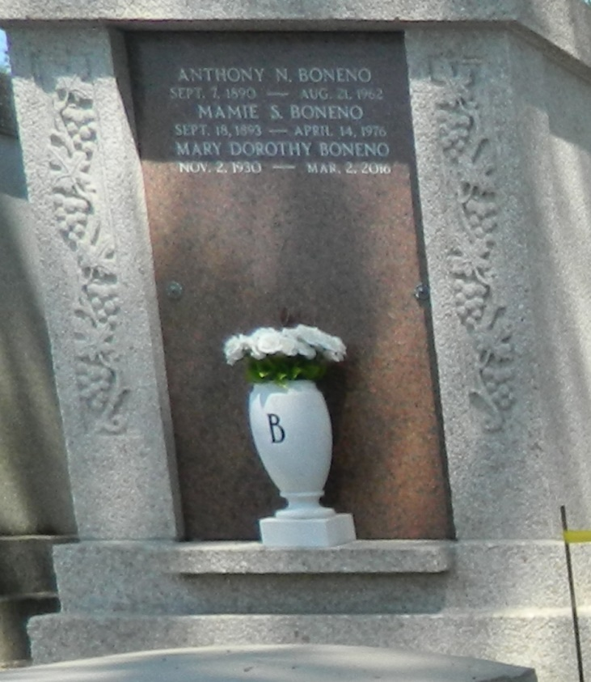
Mary Dorothy Boneno, 85, passed away on March 2, 2016. A native and lifelong resident of Garyville, she was the daughter of the late Anthony N. Boneno and Mamie Boneno. Besides her parents, she was also preceded in death by one brother, Luke A. Boneno.
She is survived by one brother, Richard N. Boneno of Garyville; one sister-in-law, Anna Belle Dupre Boneno; nephews Barry Boneno of Winston-Salem, N.C., and Gary Boneno of Charlotte, N.C.; nieces Patricia Gilleland of Williamson, Ga., and Pamela Justice of Landrum, S.C.; and many great nieces, nephews and friends.
Boneno is best remembered as "Dot" or "Dot-Tee" by her many friends and patrons of her father's grocery and service station on River Road in Garyville, in which she worked for many years. She enjoyed swimming and was an avid sports fan, following the Saints and Tulane religiously. She also enjoyed the Olympics, especially ice skating and gymnastics.
Boneno was a very good cook; her gumbo and bread pudding were highly praised, but she was more than a simple housekeeper. Her interests were worldwide, and she held an opinion on everything from politics, daily news, music and even airplane and car designs, especially her beloved 1966 Ford LTD, which she kept in perfect condition until her eyesight failed. She will be greatly missed by her nephews and nieces, whose birthdays she always remembered by sending them humorous happy birthday cards, which she enjoyed selecting.
A short private graveside service was held before burial in the family tomb in St Peter Cemetery in Reserve.
To view or sign the online guest book, visit milletguidry.com.
L'Observateur (La Place, LA) - Friday, March 4, 2016
Contributed by Jane Edson

