Lawrence Joseph Bourgeois

October 22, 1892 – November 5, 1947

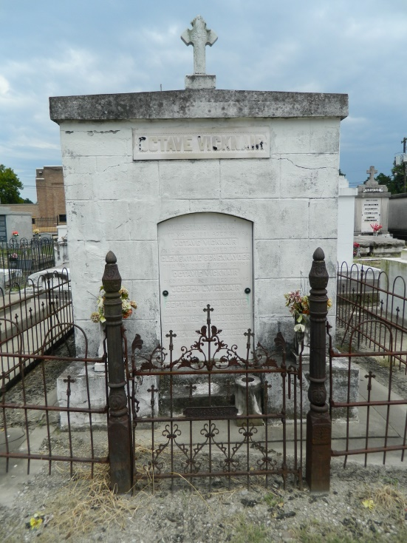 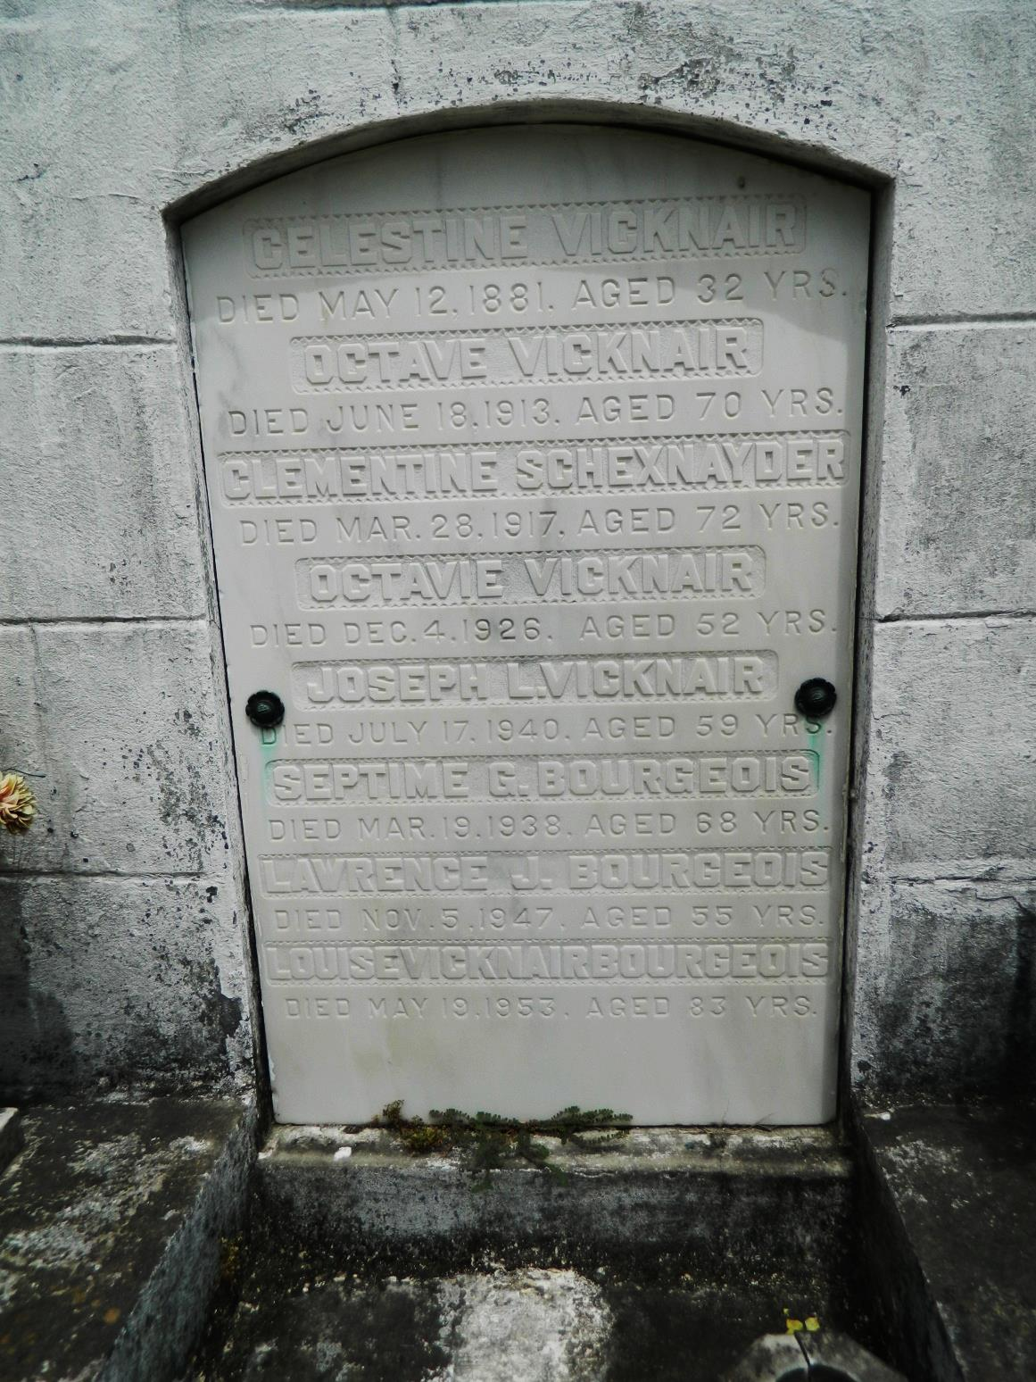

Lawrence J Bourgeois, of 1450 N Rocheblave St, New Orleans, died Wednesday 5 Nov 1947 at 4:45 pm. He was the son of Louise Vicknair and the late Septime G Bourgeois and the brother of Mrs T Ray Cary, Mrs Carl Haase, Mrs Leonard Bankston, Mrs Frances Pareti, Eloise, Gertrude, Thomas, Octave and Wilfred Bourgeois. He was a native of Ascension Parish, Louisiana, and a resident of New Orleans for many years. Services were Friday 7 Nov 1947 at St Peter Catholic Church in Reserve, Louisiana, with interment in St Peter Cemetery, Reserve.

The Times-Picayune (LA), 6 May 1947

Contributed by Dwayne Montz