Nolan "Jimmy" Bourgeois

June 4, 1931 - November 11, 2019

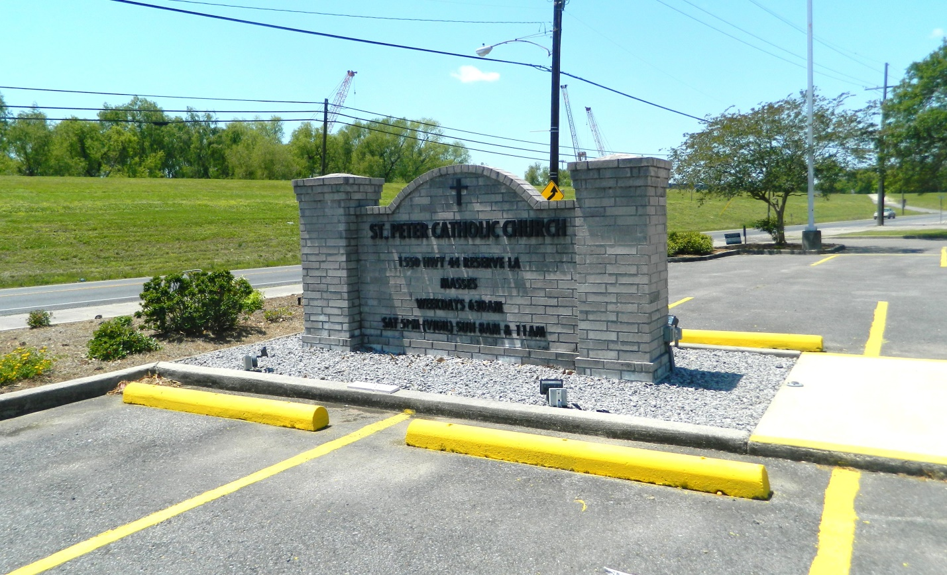

Nolan “Jimmy” Bourgeois, age 88, passed away on Monday, November 11, 2019 at the Southeast Louisiana Veterans Home in Reserve, LA. Nolan was a native and resident of Garyville, LA. He proudly served in the U. S. Army as a Sergeant during the Korean War and later retired from Marathon Oil Company.  
 Beloved husband of 63 years to Betty Warner Bourgeois. Loving father of Gregory J. Bourgeois (Jan), Trena Cristina (David), Angela Millet (Randy), Nolan A. Bourgeois, Wendy St. Pierre and Shannon Tregre (Steve). Grandfather of Kelly Roussel (Lee), Lauren Wisecarver (Mike), Ian Baker, Monica Roussel (Dustin), Bridget Millet, Brandon St. Pierre, Shelby Stewart (Ryan) and Shaine Tregre. Great grandfather of Hallie, Parker, Karson, Kinsley and Kendyl Roussel and Sophie Stewart. Son of the late Paul and Martha Tamplain Bourgeois. Brother of Larry Bourgeois (the late Yvonne), Albert Bourgeois (Marietta), Lynn Bourgeois (Delores) and the late Doris Madere Cambre (Douglas), Rita Madere (the late Antoine), Roland Bourgeois (the late Eunice), Hubert Bourgeois (Mary Ann) and Warren Bourgeois (the late Clemonse). Also preceded in death by his brother-in-law and sister-in-law, Rupert “Mickey” and Leah Warner.  
 The family would like to extend a special thanks to the staff of the Southeast Louisiana Veterans Home.  
 Relatives and friends are invited to attend the visitation at Millet-Guidry Funeral Home, 2806 W. Airline Hwy, LaPlace on Wednesday, November 13, 2019 from 5:00 p.m. to 8:00 p.m. and at St. Hubert Catholic Church, 176 Anthony F. Monica St., Garyville on Thursday, November 14, 2019 from 9:00 a.m. to 11:00 a.m. with the Funeral Mass to immediately follow at 11:00 a.m. Interment in St. Peter Cemetery, Reserve, LA.

Millet-Guidry Funeral Home, LaPlace, LA; November 12, 2019