Septime Gustave Bourgeois

July 24, 1868 – March 19, 1938

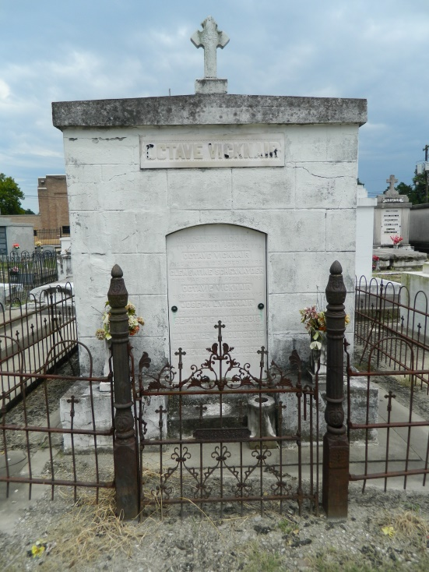 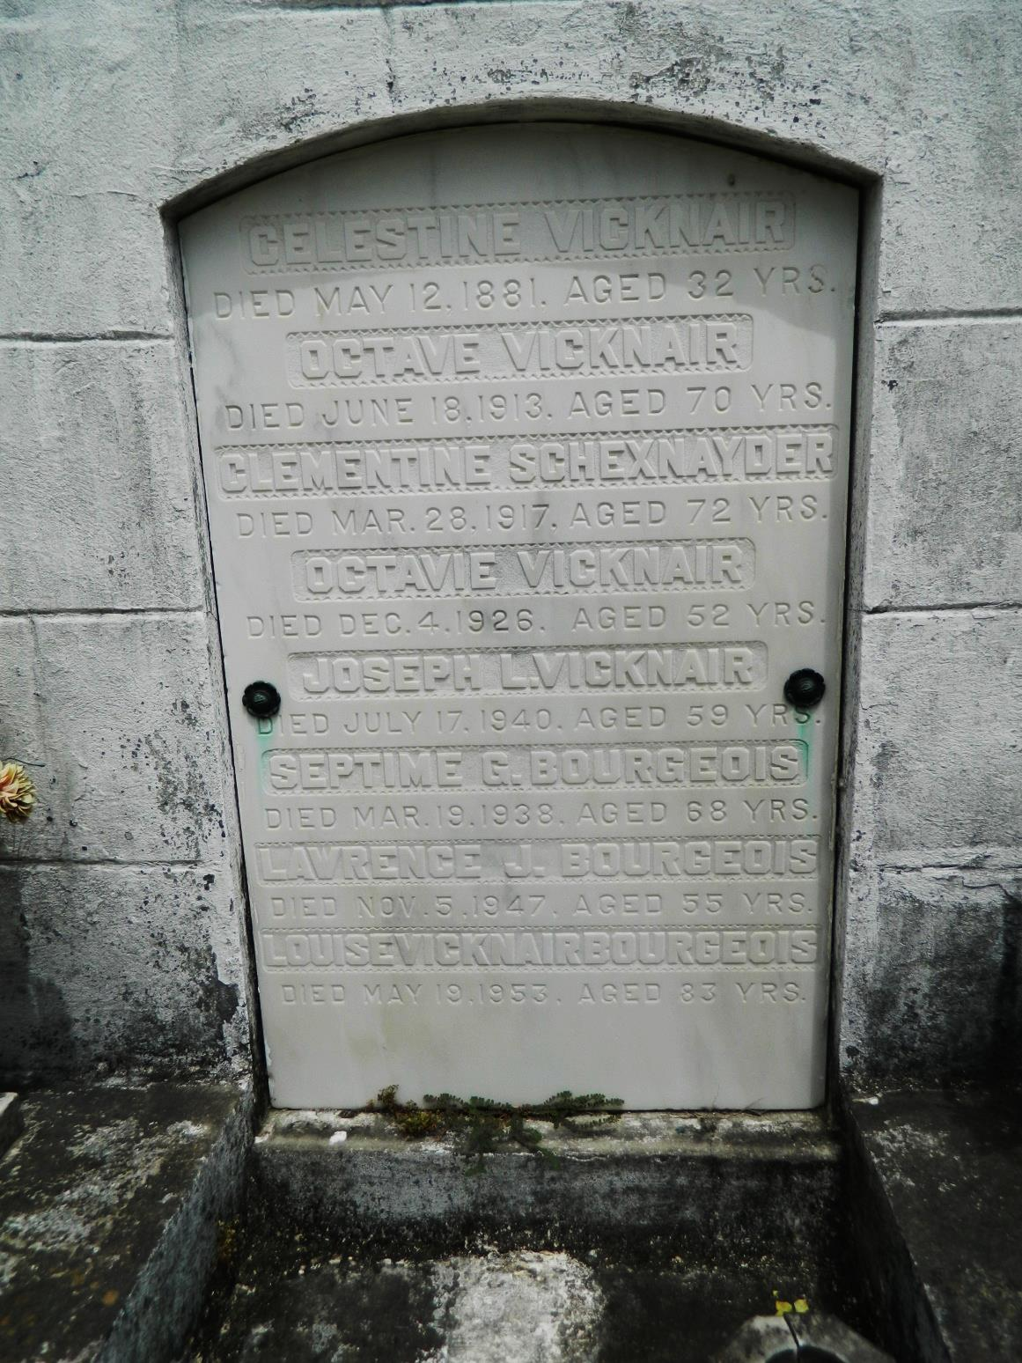

BOURGEOIS - On Saturday, March 19, 1938, at 6:20 o'clock a.m., SEPTIME G BOURGEOIS, of 1450 N Rocheblave, husband of Louise Vicknair, father of Mrs T Ray Cary, Mrs Carl Haase, Mrs L Bankston, Mrs L Pareti, Heloise, Gertrude, Lawrence, Thomas and Octave Bourgeois and Wilfred Bourgeois of New York city, also survived by several grandchildren, age 67 years, a native of Mount Airy, La, and a resident of this city for years. Remains will be forwarded from the funeral home of Albert E Briede and Son, Inc, 1160 Camp, on Sunday, March 20, 1938, at 8:30 o'clock a.m., via auto to Reserve, La, for interment.

The Times-Picayune (LA), 20 Mar 1938, p 6

Contributed by Dwayne Montz