Walter C. Bourgeois

June 12, 1937 – August 11, 2007

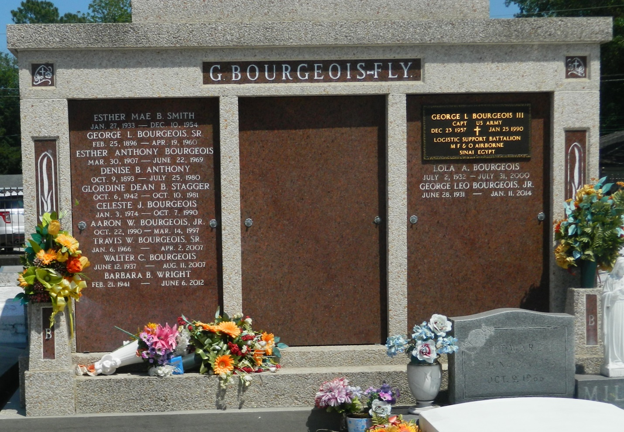

Walter C. Bourgeois on Saturday, August 11, 2007, at his home in LaPlace, LA. Son of the late Esther Anthony and George Bourgeois. Husband of Mercedes R. Bourgeois. Father of Bryan, Renee, Stacey, Barry and Arlette Bourgeois. Brother of George Bourgeois, Wallace Bourgeois, Barbara Wright, the late Hester Smith and Gloria Dean Staggers. Also survived by 7 grandchildren, 2 great grandchildren and a host of nieces, nephews, other relatives and friends. Age 70 years. A native and resident of LaPlace, LA.  
  
Relatives and friends of the family, also priests and parishioners of St Joan of Arc Catholic Church, and all neighboring churches are invited to attend the Mass of Christian Burial at St Joan of Arc Catholic Church, 529 West 5th Street, LaPlace, LA on Saturday, August 18, 2007, at ll:00 AM. Fr. Billy O'Reagan, Celebrant. Interment St Peter Cemetery, Reserve, LA. Visitation at the above named church from 9:00 AM until Mass time.  
  
SERVICED BY ROBOTTOM

Times-Picayune, The (New Orleans, LA) - Friday, August 17, 2007

Contributed by Jane Edson