Antoine W. Brady Sr.

August 2, 1917 – June 20, 2001

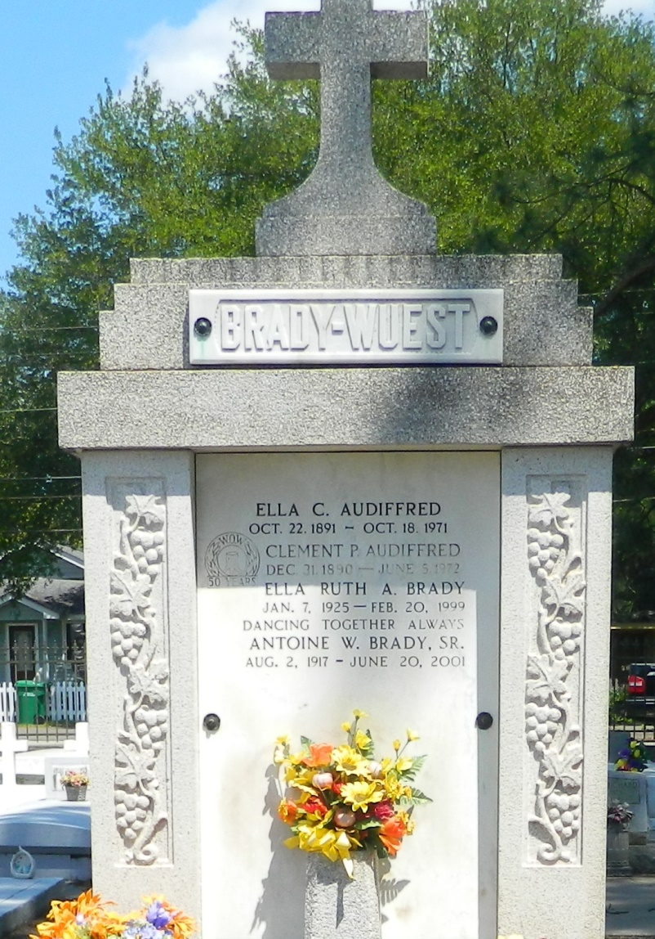

Antoine W. Brady, Sr., a resident of Reserve, died Wednesday, June 20, 2001. He was 83 and a native of Hester. Visiting at Millet-Guidry Funeral Home, 2806 W. Airline Highway, LaPlace, from 6 p.m. to 10 p.m. Thursday and after 9 a.m. Friday. Religious services at St. Peter Catholic Church, Reserve, at noon Friday. Burial in church cemetery.

He was the beloved husband of the late Ella Ruth Audiffred Brady; father and father-in-law of Antoine "Pop Top" and Denise Brady and Darlin Brady-Caro and Ronald Caro; grandfather of Merrill and Brian Brady, Lori Brock and Julia Caro and the late Benjamin Caro; great-grandfather of Matthew Brady and Kailey Brock; brother of Edvige LeBlanc, Antoinette "Kit" Kling, Melda Petit and Marie Poche; son of the late Eugenie and Moise Brady; and brother of the late Albert "Snow," Eddie and Eugene "Gene" Brady, Lillian Weber and Rita Madere.

Advocate, The (Baton Rouge, LA) - Thursday, June 21, 2001

Contributed by Jane Edson