John T. Breithaupt

October 12, 1919 – January 13, 2015

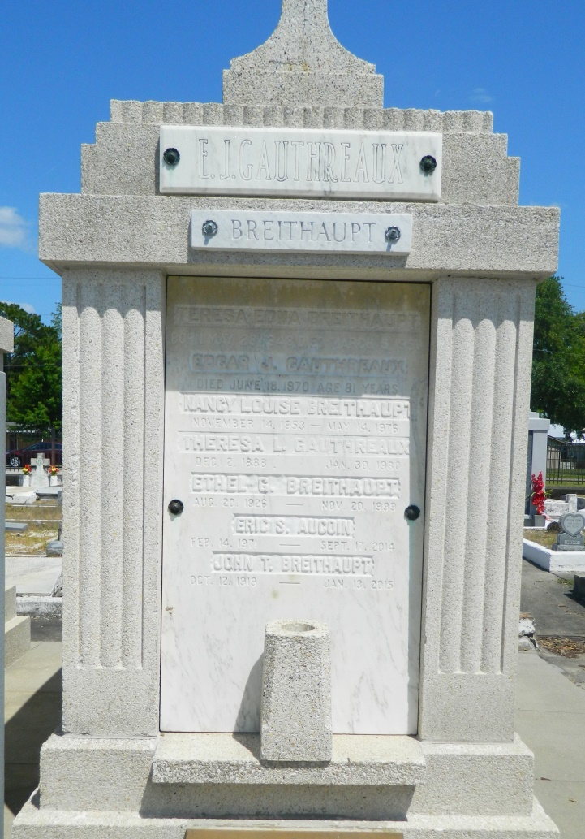

John T. Breithaupt passed away on January 13, 2015 at the age of 95 years. Beloved husband of the late Ethel "Tiny" Gauthreaux Breithaupt. Father of Alice B. Aucoin, the late Nancy Breithaupt and Theresa Breithaupt. Grandfather of Jennifer Eckhart (Corey) and the late Eric Aucoin. Great-grandfather of Peyton and Piper Eckhart. Brother of the late Edna Schneider and George Breithaupt. Son of the late Theodore and Edna Packard Breithaupt. Also survived by other loving relatives and friends.  
 John retired from Shell Oil as a mechanical engineer. He was a member of A.A.R.P. where he was a tax volunteer. John loved to cook and was known for his love of bow ties. He will be sadly missed by all who knew him  
 Relatives and friends are invited to attend the visitation at MOTHE FUNERAL HOME, 2100 Westbank Expy., Harvey, LA on Monday, January 19, 2015 from 11 AM to 1 PM. Services will follow in the funeral home chapel. Interment St. Peter Cemetery in Reserve, LA. For directions or to view and sign the online guest book, please visit: [www.mothefunerals.com](http://www.mothefunerals.com/).

Times-Picayune, The (New Orleans, LA) - Sunday, January 18, 2015

Contributed by Jane Edson