Florence (Duhe) Brignac

February 19, 1927 – January 24, 2003

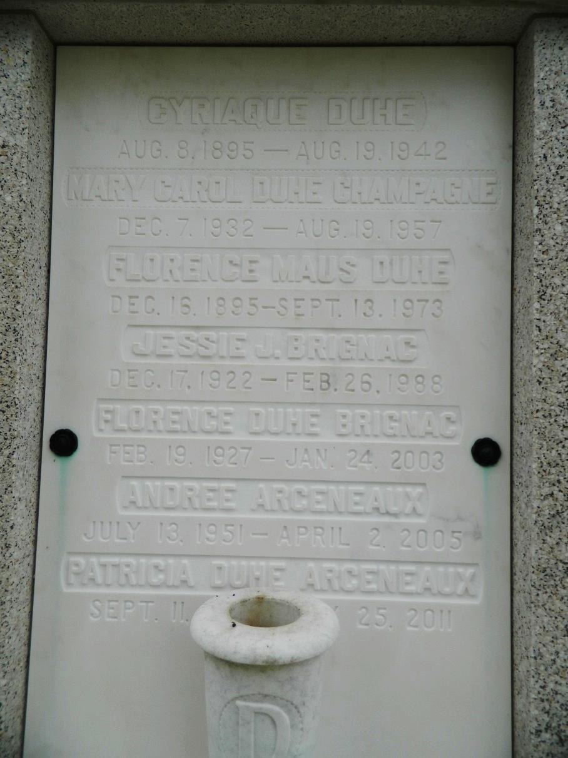

Florence Duhe Brignac, on Friday, January 24, 2003 at 8:10 p.m. Wife of the late Jessie J. Brignac. Mother of John Jeffrey Brignac and Tavi Brignac Benjamin. Mother-in-law of Kate Brignac and Earl Benjamin. Daughter of the late Cyriaque and Florence Duhe. Sister of Patricia Duhe Arceneaux and the late John Richard Duhe and Carol Duhe Champagne. Also survived by 7 grandchildren. Age 75 years. A native of Reserve, LA and a resident of Kenner, LA.   
 Relatives and friends of the family are invited to attend the Funeral Mass at Leitz-Eagan Funeral Home Chapel, 4747 Veterans Blvd., near Clearview, on Tuesday, January 28, 2003 at 11:00 a.m. Visitation will begin at 9:00 a.m. Interment to follow at St. Peter Catholic Cemetery in Reserve, LA.

Times-Picayune, The (New Orleans, LA) — Sunday, January 26, 2003

Contributed by Jane Edson