Julia (Lasseigne) Buntin
May 8, 1911 – March 12, 1987

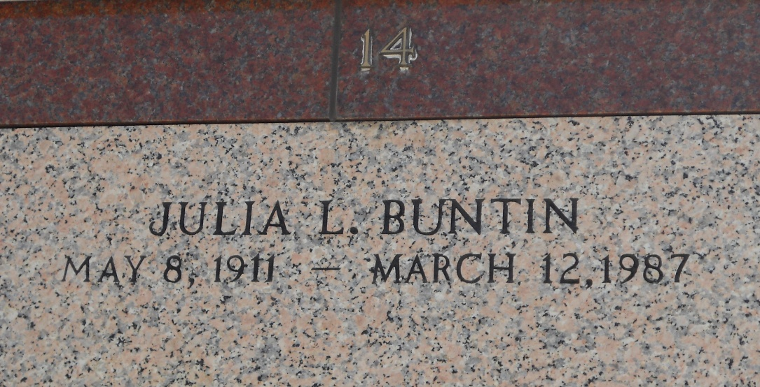
Photo by Team T-Lo
Julia Lasseigne Buntin on Thursday March 12, 1987 at 5:30 o'clock p.m. Wife of Joddie Buntin. Mother of Barbara Watcher. Sister of Mrs. Adine Pisani, James Lasseigne, Mrs. Florence Mabile, and Harvey Lasseigne. Also survived by 3 grandchildren, nieces and nephews. Age 75 years. A native of St James Parish a resident of Reserve, Louisiana for the past 23 years.
Relatives and friends of the family are invited to attend the funeral services from Miller Funeral Home of Reserve, Louisiana on Saturday March 14, 1986 at 1:00 o'clock p.m. Followed by a Mass Christian burial at St. Peter Catholic Church Interment in St. Peter Catholic Church Cemetery. Friends may call from 11:00 - 1:00 p.m. On Saturday
Times-Picayune (New Orleans, Louisiana)
Saturday, March 14, 1987, page 31

