Eddie T. Gautreaux
1915 – February 20, 2004

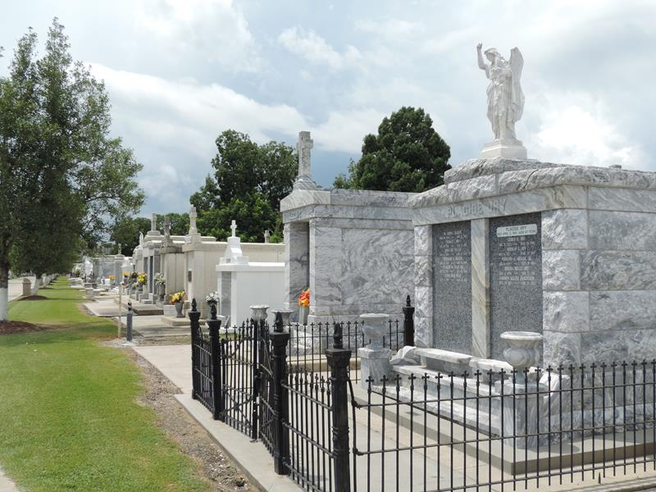
Photo by Team T-Lo

Eddie T. Gautreaux On Friday, February 20, 2004 At 10:51pm.
Beloved Husband Of The Late Emma Gautreaux. Father Of Johnny Gautreaux, Sonya Langley And Linda Allen. Son Of The Late James And Edna Gautreaux. Brother Of The Late Elsie Labat, Roussell Gautreaux And Lloyd Gautreaux. Also Survived By 5 Grandchildren And 2 Great Grandchildren. Age 89 Years. A Native Of Thibodaux And A Resident Of Reserve For The Past 80 Years.
Relatives And Friends Of The Family Are Invited To Attend Services. Visitation At Millet-Guidrey Funeral Home, 2806 W. Airline Hwy., Laplace, La On Sunday, February 22, 2004 From 5pm Until 10pm And On Monday From 8am Until 9:15am Followed By Religious Services At St. Peter Catholic Church, Reserve, La At 9:30am. Burial In The Church Cemetery.
Times Picayune, New Orleans, Louisiana
February 22, 2004

