Dowie Louis Gendron

July 29, 1927 – January 9, 2011

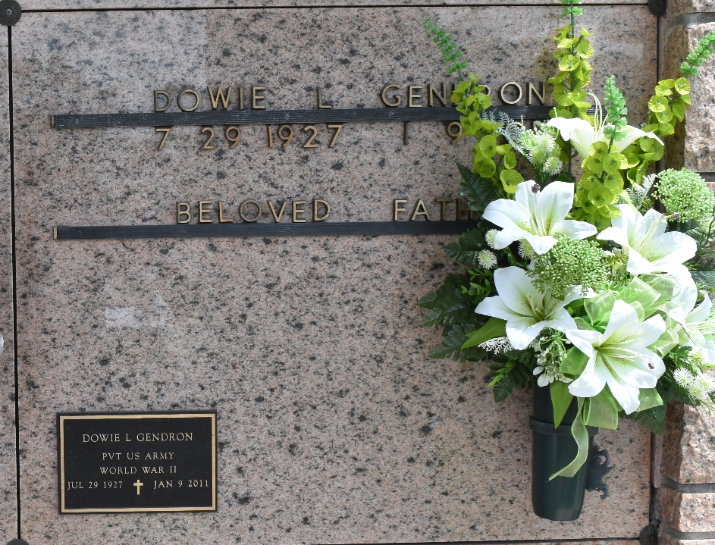

Dowie Gendron passed away on Sunday, January 9, 2011.

Beloved husband of the late Annabelle Edler Gendron. Father of Dowie (Dee) II and DavidvGendron, Sandra Ratcliff (J.D.), Anne Iris Terrio (Barry), Nancy Holmes (Barry), Geraldine Cox (Henry), Glenda Arcuri (Len) and Sundy Fitch (Ron). Also survived by 14 grandchildren and 5 great grandchildren.

Son of the late Jorda and Angeline Gendron. Brother of the late Mildred Keller, Earline Duhe, Roline and Roy Gendron. Age 83 years. A native and resident of LaPlace.

Relatives and friends, also employees of St. John the Baptist Parish and School Board are invited to attend services. Visitation at Millet-Guidry Funeral Home, 2806 W. Airline Hwy., LaPlace, on Tuesday, January 11, 2011 from 5:00pm until 9:00pm and on Wednesday from 8:00am until 9:45am followed by a Mass at St. Joan of Arc Catholic Church in LaPlace at 10:00am. Burial in St. Peter Cemetery in Reserve.

The Times-Picayune, New Orleans, Louisiana

January 12, 2011