Juliette (Delaneuville) Granier

July 8, 1908 – October 2, 1994

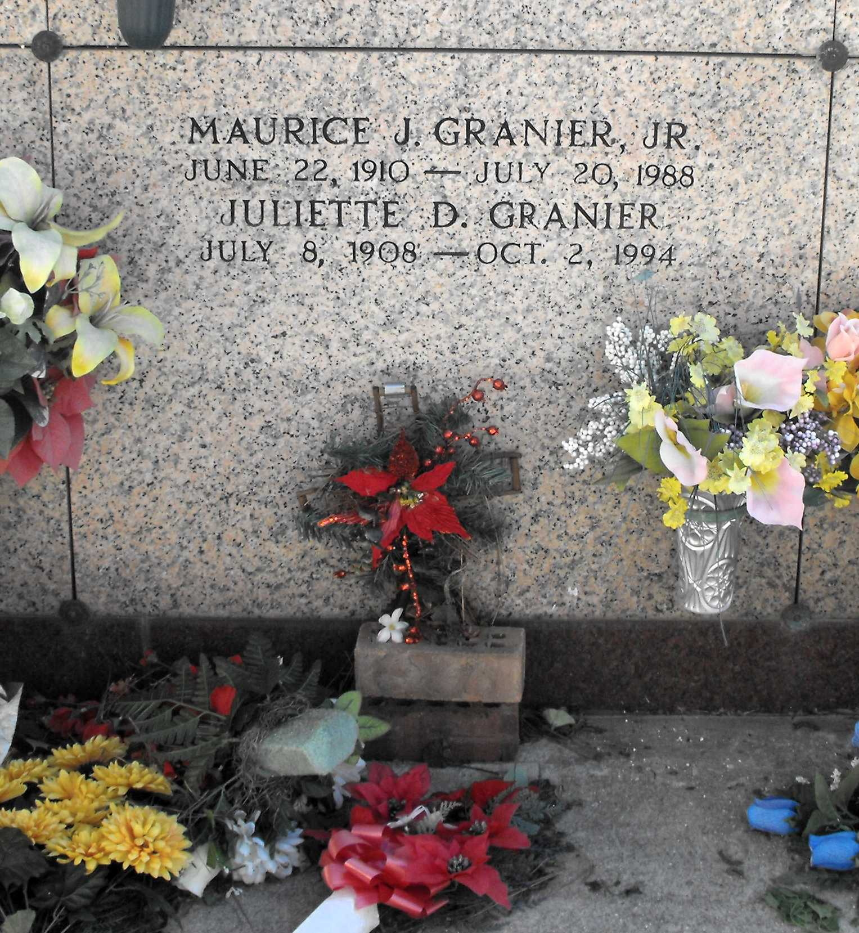

Photo by Mary Agnes Hammett

Juliette Delaneuville Granier died Sunday 2 Oct 1994 at 4:00 pm at age 86 years. She was a native and resident of Reserve, Louisiana, and wife of the late Maurice Granier Jr. She was the mother of Robert and Ralph Granier, Janet G Clark and the late Barbara Ann Granier. She was the daughter of the late Adolph and Elise Laiche Delaneuville and the sister of the late Horace, Pelham Sr, Joseph Benoit and Igar Delaneuville, Valvet Savoie and Letisha Vicknair. Also survived by 14 grandchildren and 20 great-grandchildren.

Services were Tuesday 4 Oct 1994 with interment in St Peter Cemetery, Reserve.

The Times-Picayune, New Orleans, Louisiana

3 Oct 1994