Amelia Gray
1930 – March 15, 2004

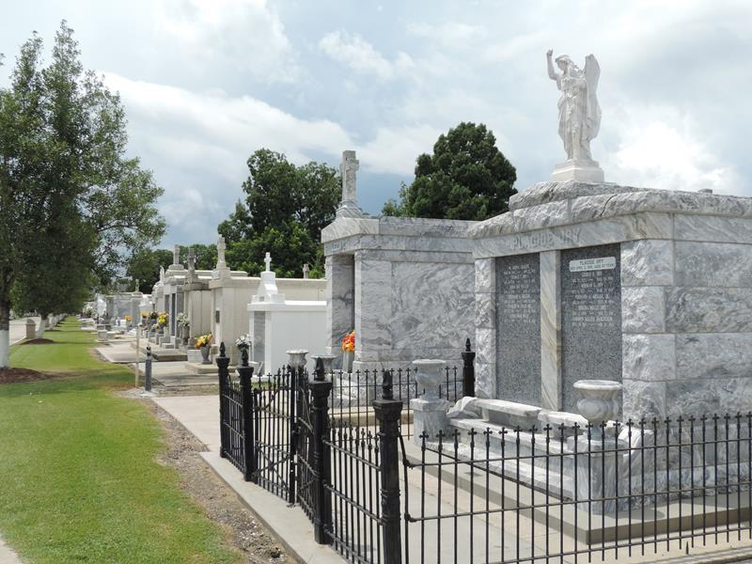
Photo by Team T-Lo

On Monday, March 15, 2004 At River Parishes Hospital, Laplace, La.
Daughter Of The Late Dennis Gray, Sr. And Harriet Bywater. Beloved Sister Of Sedonia Songy, Lois And Robert Gray, Sr. All Of Reserve, La. Survived By Uncles, Aunts, Sister-In-Law, Brother-In-Law, A Host Of Nieces, Nephews, Other Relatives And Friends. Relatives And Friends Of The Family.
Priest And Parishioners Of Our Lady Of Grace Catholic Church; Employees Of Kelly Educational Staffing, Home Depot Store, St. John Parish School Board; And Faculty And Staff Of Fifth Ward Elementary School Are Invited To Attend The Funeral Mass Of Christian Burial On Thursday, March 18, 2004 At 11:00 A.M. Father Joseph Rodney, S.S.J., Pastor - Celebrant. Visitation At The Above Named Church From 10:00 A.M. Until Mass Time. Interment St. Peter's Cemetery, Reserve, La. Serviced By Robottom.
The Times Picayune, New Orleans, Louisiana
March 17, 2004

