Jeanne (Becnel) Gregoire
November 15, 1919 – January 4, 2019

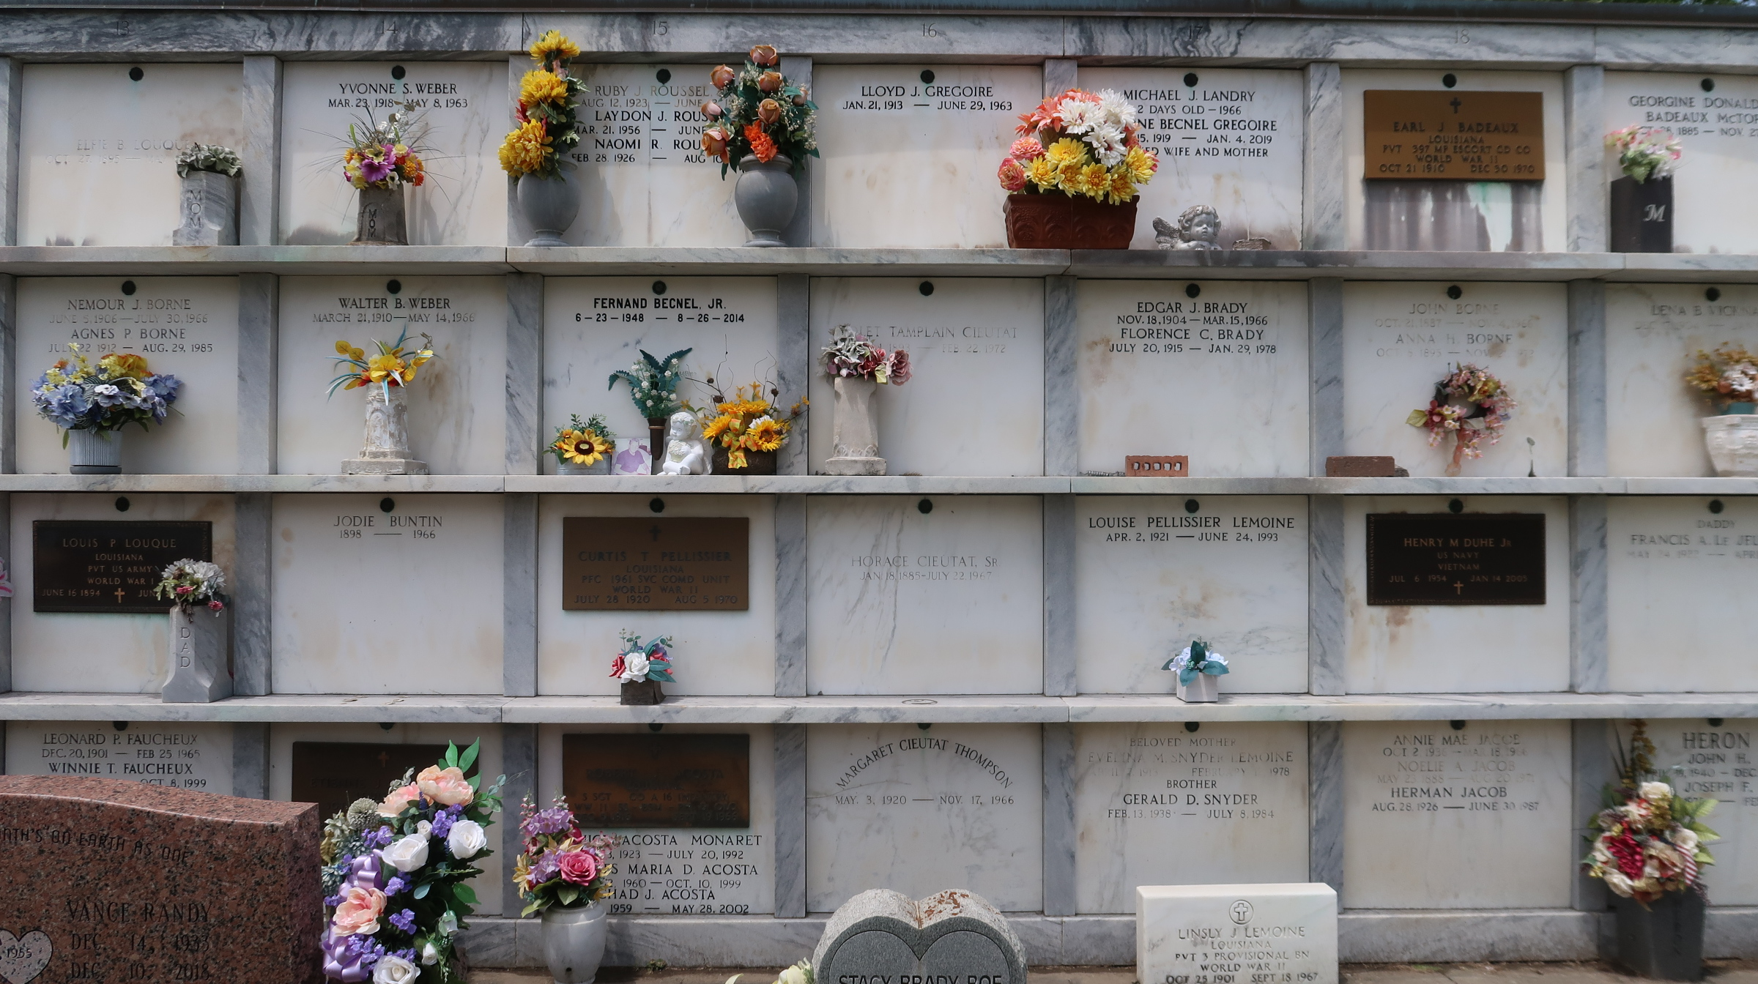

Jeanne Becnel Gregoire went home to her Heavenly Father on Friday, January 4, 2019 at the age of 99. She was a native of Vacherie and a longtime resident of Garyville.
She was a parishioner and member of the Altar Society at St. Hubert Catholic Church. Jeanne was also a member of Garyville Recreation Organization, AARP, Council on Aging and Belle Oaks Garden Club. Jeanne was a very hospitable person who loved cooking and sharing meals with her family and friends.
Beloved wife of the late Lloyd Joseph Gregoire. Loving mother of Maude Rizzuto (Tom), Linda McTopy (Brian), Jenny Jacob (Donald), Jeanne Vicknair (Curtis), Larkin Gregoire (Nettie), Morgan Gregoire (Melinda), Sally Pothetes (Ed) and the late Lloyd P. Gregoire (Nettie).
Daughter of the late Edward Becnel and Corestile Stein Becnel. Sister of the late Rosemary Gravois, Mariette Becnel, Elmo Becnel, Floyd Becnel and Virgie Folse. She is also survived by many grandchildren, great grand-children, great great grandchildren, nieces and nephews.
The family would like to give a special thanks to the nurses and aides at Heart of Hospice and also a special thanks to Maude and Tom for their loving care.
Interment in St. Peter Cemetery.
Relatives and friends are invited to attend the Funeral Mass at St. Hubert Catholic Church, 176 Anthony Monica St., Garyville on Saturday, January 12, 2019 at 11:00 a.m. Visitation will begin in church at 9:00 a.m. Interment in St. Peter Cemetery.
Donations can be made in her memory to St. Jude Children's Research Hospital, 501 St. Jude Pl, Memphis, TN 38105-9959 or visit www.stjude.org/memorial. Arrangements by Millet-Guidry Funeral Home.
The New Orleans Advocate, Louisiana
Jan. 8 to Jan. 12, 2019

