Marian Marie (Weber) Guidry
February 18, 1946 – April 30, 2009

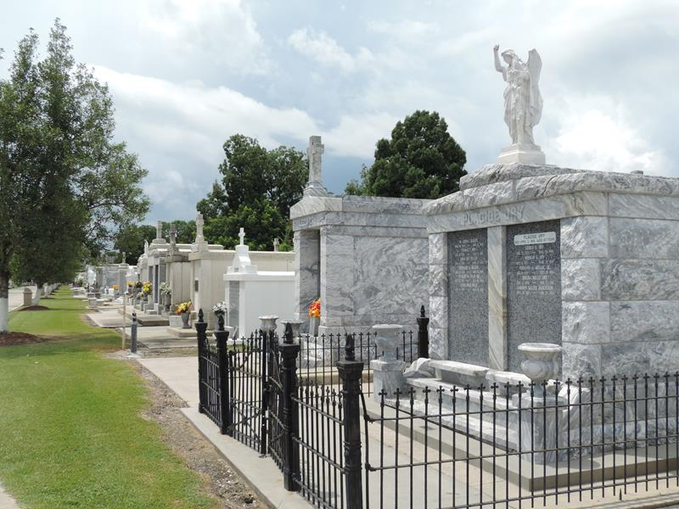

Marian Guidry passed away on Sunday, January 13,2013. She is preceded in death by her husband, Russell Guidry, Sr., her parents Bernard (Benny) and Lucette Weber and her brother Bernard J. Weber, Jr.

She is survived by her son Russell Guidry, Jr. and her siblings; Earline W. (Alexis) Jouty, Elsie W. Louque, Mildred W.(Edward "ZA") Montz, Kathleen W. (Richard) Ory, Elaine W. (Thomas) Marcantel, Irene W. (Roland) Arceneaux, and Charles W. (Andrea) Weber.

Relatives and friends are invited to attend a visitation at Sacred Heart of Jesus Church in Norco, LA on Tuesday, January 15, 2013 from 9 AM till 10:45 AM with a Funeral Mass starting at 11 AM. Burial will follow at St. Peter's Catholic Cemetery in Reserve, LA.

H. C. Alexander Funeral Home, Norco, Louisiana

