Tewfik T. Haik

July 4, 1889 – June 29, 1963

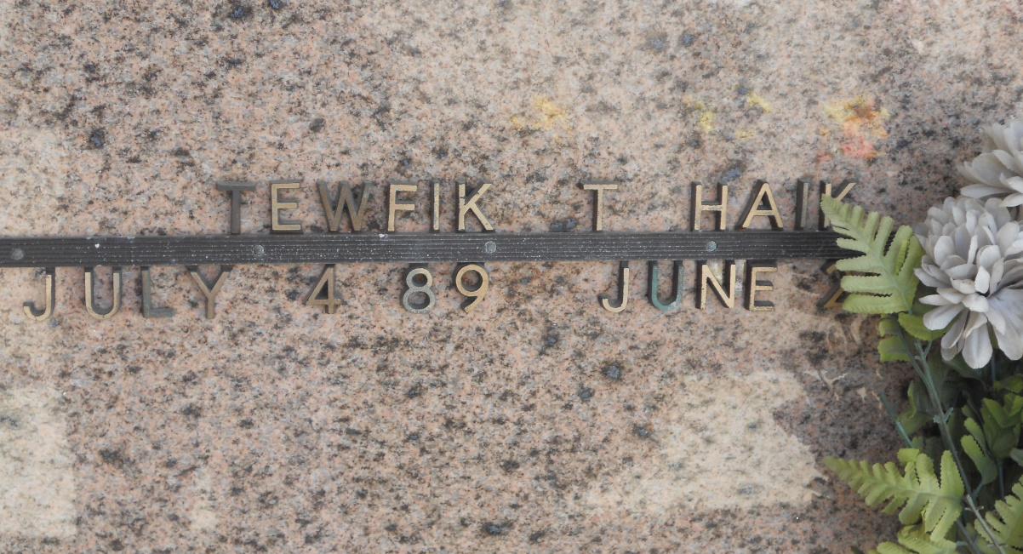

Photo by Team T-Lo

HAIK - At Hotel Dieu, New Orleans, La. On Saturday, June 29, 1963, at 4:15 o'clock p.m., TEWFIK T HAIK, beloved husband of Waddad Haik; father of Mrs. Malcolm J Donaldson of Reserve, La, and Miss Enid Haik of New Orleans, La; brother of Najeeb Haik of Edgard, La, and Alex Haik of Reserve, La. Also survived by 5 grandchildren. A native of Lebanon.

Relatives and friends of the family are invited to attend the funeral. Services from Millet Funeral Home, Reserve, La, on Monday, July 1, 1963, at 9 o'clock a.m. Religious services at St Peter Church, Reserve, La. Interment St Peter Cemetery, Reserve, La.

The Times-Picayune, New Orleans, Louisiana

30 Jun 1963, p. 2