Norma Marie (Desroches) Haydel
December 17, 1908 – August 25, 2002

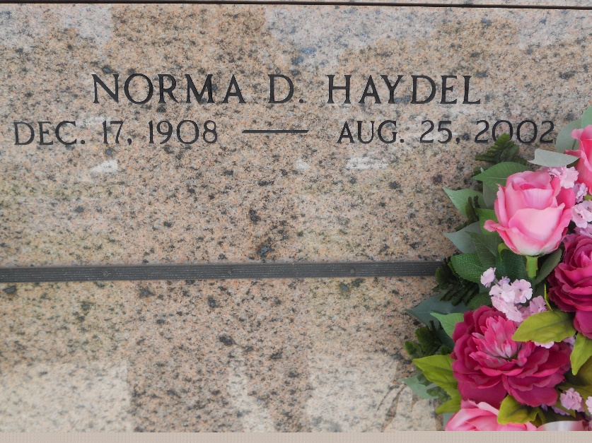
Photo by Team T-Lo

Norma Desroches Haydel On Sunday August 25 2002 At 11:50 Am.
Beloved Wife Of The Late Nelson A Haydel Sr Mother And Mother-In-Law Of Nelson And Judy Haydel, Jr., Gay And James Bergeron And Mary Lynn And Ray Prejean. Daughter Of The Late Eusebe And Colette Audiffred Desroches. Sister Of The Late Leon Desroches And Eleanor Troxclair. Grandmother Of Beth Zagata, Nancy Barron, Cindy Ryan, David And Kevin Prejean, Troy Haydel, Colette Taillon, Claudette Henry, And The Late James Bergeron Iii. Also Survived By 13 Great Grandchildren. Age 93. A Native Of Lions And Resident Of Laplace For The Past 74 Years.
Relatives And Friends Of The Family, Are Invited To Attend The Services. Visitation At St. Joan Of Arc Catholic Church, Laplace, On Wednesday, August 28, 2002 From 9 Am To 11 Am. Followed By Religious Service In The Church At 11 Am. Burial In St. Peter Cemetery, Reserve. In Lieu Of Flowers Masses Preferred Or Donations To The American Cancer Association. Arrangements By Millet Guidry Funeral Home.

Times Picayune, New Orleans, Louisiana
August 27, 2002

