Patricia (Weber) Haydel
March 18, 1937 - May 26, 2025

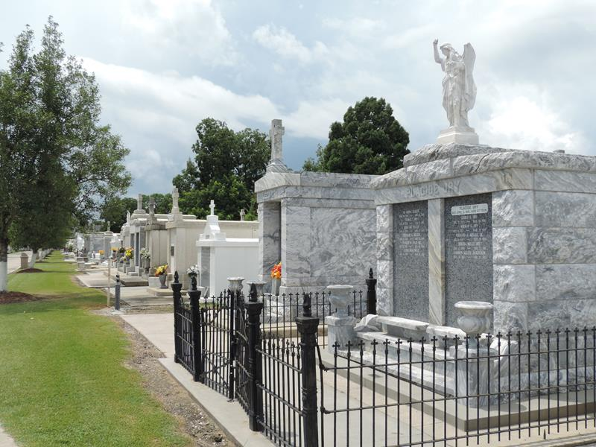

Patricia “Pat” Weber Haydel passed away peacefully on Monday, May 26, 2025 at the age of 88. She was a native and lifelong resident of Reserve, LA. Patricia was a 1955 graduate of Leon Godchaux High School. Patricia worked in New Orleans for 20 years. She also worked for ARC in LaPlace for several years and at Dupont for about a year. She loved spending time with her husband Melvin.
Beloved wife of the late Melvin Haydel for 66 years. Daughter of the late Lillian Oubre Weber and the late Alfred J. Weber. Sister of the late Gloria Weber. Survived by her godson, Randy Montz and his wife Erika.
Patricia was recently a resident of Landmark Nursing Home in Hammond, LA. We would like to express our gratitude to the nursing staff and CNA staff, especially the people who took great care of her. Also our sincere thanks to Life Source Hospice staff of Baton Rouge who helped with her care.
Relatives and friends are invited to attend the Funeral Service at St. Hubert Catholic Church, 176 Anthony F. Monica St., Garyville, LA on Thursday, May 29, 2025. Visitation will be held from 9:30 a.m. until 11:00 a.m. with the Funeral Mass to immediately follow at 11:00 a.m. Interment in St. Peter Cemetery.
Millet-Guidry Funeral Home, LaPlace, Louisiana

