Ridley T. Hebert
June 14, 1920 – July 20, 2002

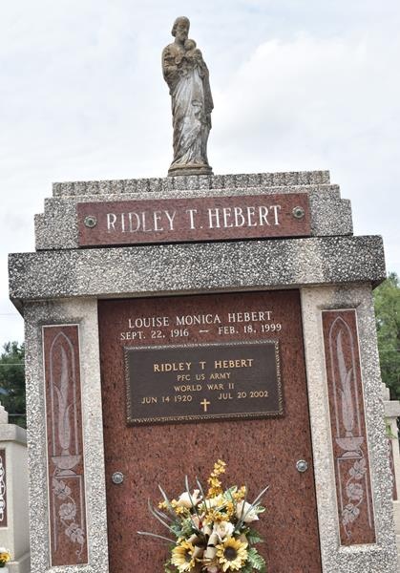

HEBERT RESERVE – Ridley T. Hebert, 82, a native of Napoleonville and resident of Reserve for the past 60 years, died July 20. He was the husband of the late Louise Monica Hebert and father of Veronica Sylvest. He was the son of the late Paul and Irma Hebert and brother of Ernest Hebert, Jeanne Talbot, Marie Millet, Shirley Naquin and the late Felix “Pete” and Robert Hebert, Mary Aucoin, Levie Cavalier, Pearl Simoneaux, Pansy Cedotal and Mildren LeBlanc. He is also survived by four grandchildren.

Services were July 23 at St. Peter Catholic Church, Reserve, with interment at the church cemetery.

L’Oservateur, LaPlace, Louisiana
July 4, 2002

