Gilbert Joseph Henry Sr.
August 1, 1927 – December 18, 2015

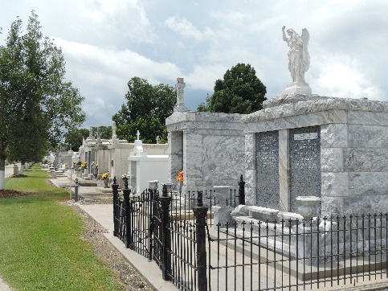

Gilbert Joseph Henry, Sr. passed away at home surrounded by his loving family on Friday, December 18, 2015. He was 88, a native of Rayne, LA and a resident of LaPlace, LA.
Beloved husband of Semay Berthelot Henry. Loving father of Rose Anna Wade (Mike), Tommy Henry (Donna), Roy Henry (Anna), Gilda Arcuri, Marie Deaton (Gerald), Elaine Burns and Gilbert 'Gil' Henry, Jr. (Libby). Son of the late Alice Leger and Lenis Henry. Brother of the late John Henry, Orita Duhon, Julius Henry, Raoul Henry, Eula 'Sister Claudette Marie' Henry, Gladys Louvierre, Aggles Guidry, Percy Henry and Rufus Henry. Also survived by 18 grandchildren, 20 great-grandchildren and many nieces and nephews.
Gilbert was awarded the Order of St. Louis Medal, a member of the Knights of Columbus (4th Degree) and was a man of Manressa for 18 years. He was a board member of Association of Retarded Citizens, Catholic Charities, Council of Aging and Ascension of Our Lord Pastoral Council (President). Sergeant Henry proudly served our country in the Army National Guard for 6 years.
Relatives and friends are invited to attend a visitation at Millet-Guidry Funeral Home, 2806 W. Airline Hwy, LaPlace on Tuesday, December 22, 2015 from 6:00 p.m. until 9:00 p.m. The Funeral Mass will be celebrated at Ascension of Our Lord Catholic Church, 799 Fairway Dr. LaPlace, LA on Wednesday, December 23, 2015 at 11:00 a.m. Visitation at the church from 9:00 a.m. until 11:00 a.m. Interment in St. Peter Cemetery. Millet-Guidry Funeral Home in charge of services.

The Times-Picayune, New Orleans, Louisiana
Dec. 19 to Dec. 20, 2015

