Cora Marguerite Hidalgo
March 8, 1920 – July 26, 1977

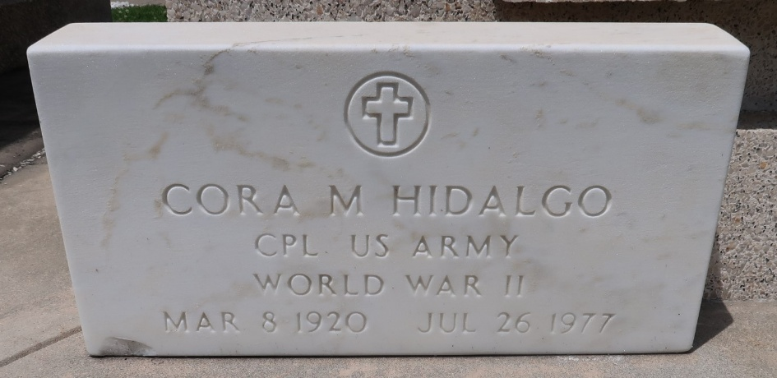

Funeral services for Cora M. Hidalgo will be today, Thursday, July 28, from the St. Peter Catholic Church in Reserve, with interment in the church cemetery. She was a native and resident of Reserve. Miss Hildalgo died July 26. She was 57 years old.
She is survived by her mother, Emma Lanoux Hidalgo; one brother, Israel ‘Pete’ Hidalgo of Reserve; two sister, Bea McIntyre of El Paso, Texas and Doris Church of Reserve.

L’Observateur, LaPlace, Louisiana
Thursday, July 28, 1977, p. 4

