O’Neil Vincent Himel Sr.
July 19, 1930 – November 18, 2024

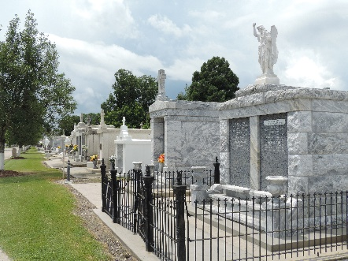

O'Neil Vincent Himel, Sr. passed away peacefully on Monday, November 18, 2024, at the age of 94. He was a native of Donaldsonville, LA, raised in Reserve, LA by Claire and O'Neil Aucoin and resident of Garyville, LA for 69 years. O'Neil was a lifelong parishioner of St. Hubert Catholic Church and sang in the choir for the last 15 years. He proudly served in the U.S. Army, during the Korean War.
Beloved husband of the late Phyllis Monica Himel, for 68 beautiful years. Loving father of Robbie Luminais (Mike), O'Neil Himel, Jr. (Deborah), Scott Himel (Christy), and the late Randy Himel (Joycelyn). The most loving grandfather of Dr. Mike Luminais, Jr. (Jill), Ryan Luminais (Hillary), Jonathan Luminais (Jamie), Katie LeLeux (Jarod), Jessica Millet (Adam), Lacey Himel, and Scott Himel, Jr. (Ashley). Son of the late Theophile and Eugenie Hebert. Brother of Connie Thibodaux (his godchild), Catherine Ward, Annette Sparks, Larry, LeRoy and Leo Himel and the late Beatrice Walker, Marie Palermo, Rita Mae Goetz, Jeanne Darcie, Cynthia Goetz, Joyce Diez, Baby Rita Himel, AJ and Linwood Himel. Son-in-law of the late Vita and Frank Monica, Sr. Brother-in-law of Carl Monica, Cookie Accardo (Sammy), Frank Monica, Jr. (Nancy), Maria Stein (Wayne) and the late Anthony Monica (Linda), Fano Monica (Joy) and Anna Monica. Also survived by 12 great-grandchildren and numerous nieces and nephews.
Relatives and friends are invited to attend the Visitation and Funeral Mass at St. Hubert Catholic Church, 176 Anthony F. Monica St., Garyville, on Thursday, November 21, 2024. Visitation at the church from 9:00 a.m. to 11:00 a.m. followed by a Funeral Mass at 11:00 a.m. Interment in St. Peter Cemetery, Reserve, LA.

Rose Lynn Funeral Services, Lutcher, Louisiana
Published on November 21, 2024

