Noe Anthony Hotard Jr.
May 23, 1894 – July 28, 1951

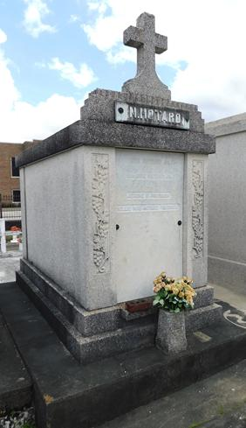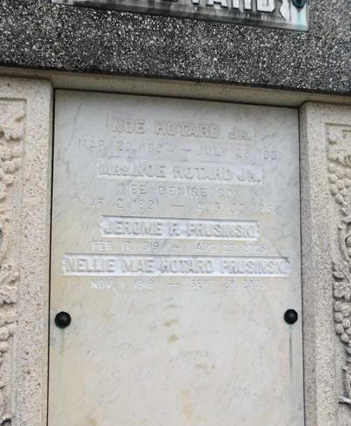

HOTARD - On Saturday, July 28, 1951, at 1:10 o'clock p.m., NOE HOTARD JR, beloved husband of Denise Cox; father of Mrs. Nellie Mae Prusinski of New Orleans, La, and Carl Hotard of Gretna, La; son of the late Noe Hotard Sr and Mary Hotard Berthelot; brother of Mrs. Nancy Puig, Mrs. Maizie Vogel, Mrs. Pauline Franck, Mrs. Blanche Mary, Mrs. Pearl Brue, Mrs. Lynn Richoux and Louis, Simon, Raymond and Frank Hotard; also survived by two grandchild-
ren; aged 57 years.

Relatives and friends of the family are invited to attend the funeral, which will take place from the Millet Funeral Home, Reserve, La, on Sunday, July 29, 1951 at 5 o'clock p.m., followed by religious services at St Peter's church, Reserve, La. Interment in St Peter's cemetery, Reserve, La.

The Times-Picayune, New Orleans, Louisiana
29 Jul 1951, p 10

