Septime Raymond Hotard
January 23, 1893 – August 16, 1985
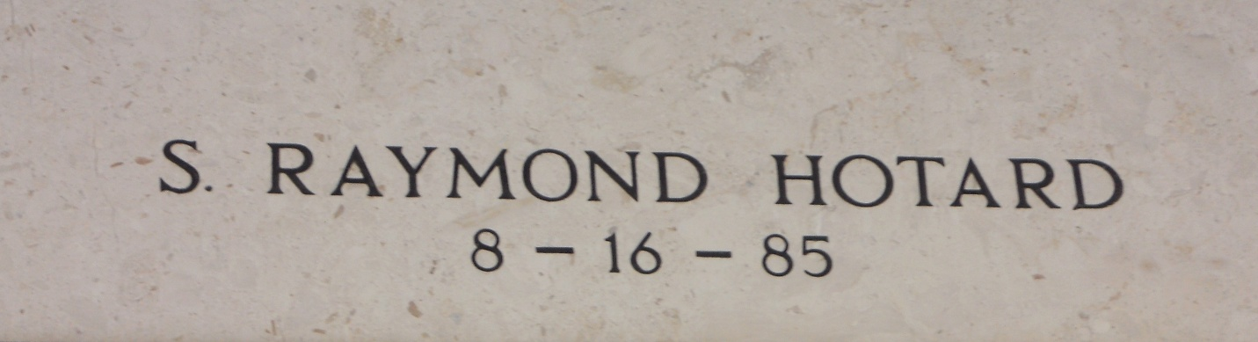

HOTARD - Septime Raymond Hotard, on August 16, 1985, at 3 o'clock a.m., beloved husband of the late Amelia Haydel Hotard; brother of Nancy Puig, Blanche Mary, Pauline Frank, Pearl Brue, all of New Orleans, LA; half-brother of Simon Hotard of Reserve, LA and Azalea Schwall of Gainesville, FL and the late Maizie Vogel, Louis Noe Jr, Frank Hotard and Letty Richoux; age 92 years; a native of Laplace, LA and a resident of Ponchatoula, LA for the past 20 years.

Relatives and friends of the family are invited to attend the Funeral and Religious Services at Millet Funeral Home, Reserve, LA, on Saturday, August 17, 1985 at 10 o'clock a.m. Interment in St Peter Cemetery, Reserve, LA.

The Times-Picayune, New Orleans, Louisiana
August 17, 1985, p. 31

