Sidney Joseph Hotard Sr.
December 3, 1923 – January 29, 2009

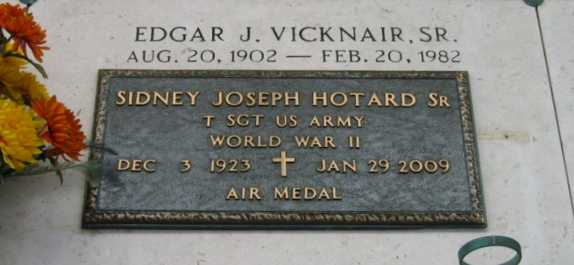
Photo by Bobby

HOTARD Sidney Joseph Hotard Sr., age 85, died Thursday, January 29th at his home in Ponchatoula, LA. Mr. Hotard was born December 3, 1923 in LaPlace, Louisiana. He was a resident of Reserve, LA and Convent, LA before moving to Ponchatoula.
He was a WWII veteran having served in the U.S. Army Air Corps and was a lifetime member of the Lutcher VFW. Many residents of the River Parishes depended on Mr. Hotard and the Hotard Bus Line for their transportation to New Orleans. He was also an employee of Krauss Department Store for 38 years before retiring in 1988. Mr.
Hotard is survived by his loving wife of 63 years, Dorothy Vicknair Hotard; and their five children and spouses: sons, Sidney Jr., and Marie Nelson Hotard, Lawton and Anita Ernst Hotard, Callen and Coleen Martin Hotard; and daughters, Nadine and Daryl Higgins and Rhenda and Paul Hodnett. He is also survived by 12 grandchildren, six great grandchildren, one brother, Henry Hotard and two sisters, Marie Hotard Sutton and Rita Hotard. Preceded in death by his parents, Etienne X. Hotard and Regina Simon Hotard, two brothers: Albert Hotard and Etienne (State) Hotard, and two sisters: Amanda Hotard Audiffred and Lucille Hotard Williamson.
Visitation was held, Friday, January 30th, 2009 from 6:00 pm - 9:00 pm at Harry McKneely and Son, Inc. Funeral Home, Ponchatoula, LA. Visitation will also be held today on Saturday, January 31st from 9:00 am - 10:00 am at St. Joseph Catholic Church Ponchatoula, LA, followed by Funeral Services at 10:00 am. Interment to follow at St. Peter Cemetery, Reserve, LA. In lieu of flowers, masses or donations to St. Joseph Hospice, 19405 Helenberg Rd., Suite 206, Covington, LA 70433, are preferred.
Times Picayune, New Orleans, Louisiana
January 30-31, 2009

