Joseph Daniel Hughes, Sr.
March 10, 1930 – July 26, 2003

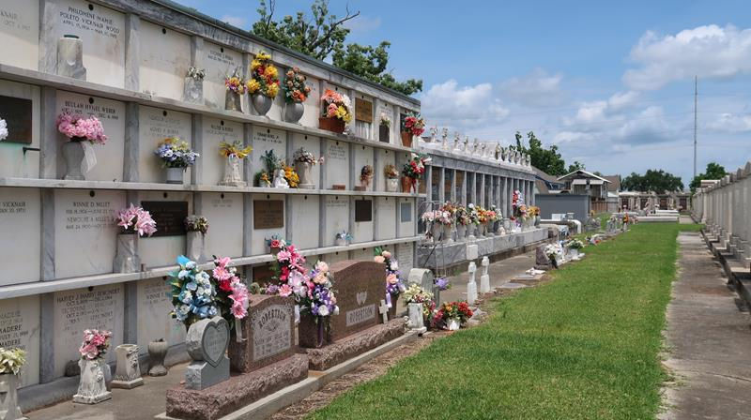

Joseph D. 'Papa-Joe' Hughes, Sr. Passed Away At 4:35 Pm On Saturday, July 26, 2003 At East Jefferson Hospital. Age 73 Years.
Loving Father Of Cheryl H. Mulkey, Craig, Carla, Christie, Joseph Jr. And Jeffery Hughes. Grandfather Of William 'Billy' And Shane Mulkey, Andrew Canfill, Tonya, Craig Jr., Alyssa And Theresa Hughes. Great Grandfather Of William 'Billy III' And Alyssa Mulkey. Beloved Brother Of Daniel Hughes And Dorothy Hartenstein, And A Host Of Nieces, Nephews, Aunts And Uncles.
Preceded In Death By His Parents Daniel And Theresa Hughes. Retired Employee Of Nopsi 'Gas Dept.' And A Navy Veteran Of WWII And The Korean War.
Relatives And Friends Of The Family Are Invited To Attend Services. Visitation At Millet-Guidry Funeral Home, 2806 W. Airline Hwy., Laplace, La. On Saturday, August 2, 2003 From 10:00 Am Until Noon, Followed By Religious Services In The Funeral Home Chapel At 12:00 Noon. Burial At St. Peter Cemetery, Reserve, La.

The Times-Picayune, New Orleans, Louisiana
August 1, 2003

