John C. Humphries
May 13, 1929 – March 23, 2015

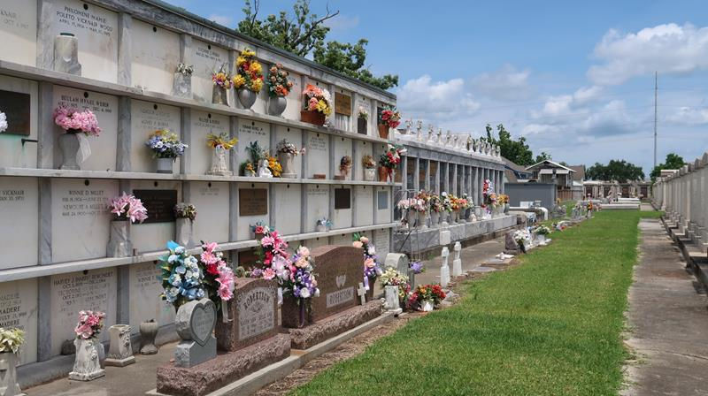

John C. Humphries passed away on Monday, March 23, 2015 at the age of 85. He was a native of South Carolina and a resident of LaPlace, LA. He served in the U. S. Navy during the Korean Conflict, retired from Kaiser Aluminum and was one of the founding members of the Riverlands Golf and Country Club.
Beloved husband of Mary Marse Humphries for 55 years. Loving father of Faye H. Mixon of Columbia, SC and Valerie H. Stone of San Francisco, CA. Grandfather of Michael C. Hiller of Blythewood, SC and Hunter Ludington of San Francisco, CA. Son of the late J.C. and Sara Wright Humphries. Brother of Juanita Holcumb of Savanna, GA, W. Kenneth Humphries and his wife Emma of Columbia, SC and the late Milton Humphries, Gordon Humphries and Edith H. Clontz.
The Funeral Mass will be held at St. Peter Catholic Church, 1550 Hwy 44, Reserve on Wednesday, March 25, 2015 at 11:00 a.m. Visitation will begin in church at 10:00 a.m. Interment in St. Peter Cemetery. In lieu of flowers, donations preferred to the church.

Millet Guidry Funeral Home, LaPlace, Louisiana

