Rowanna (Deslattes) Hymel
August 3, 1929 – September 8, 2006

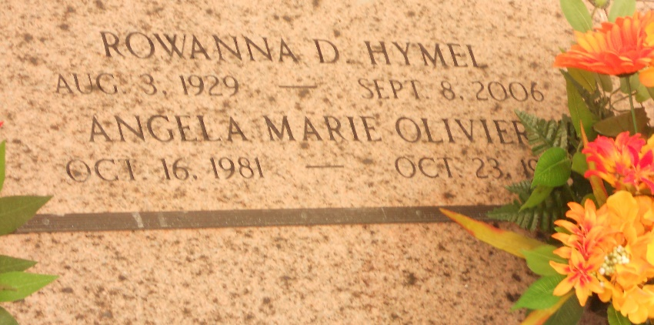
Photo by Team T-Lo

Rowanna Deslatte Hymel on Friday, September 8, 2006 at 8:00 p.m.
Beloved wife of Clyde Hymel. Loving mother and mother-in-law of Ronnie and Brenda (Babin) Hymel, Garyville, LA, Kerry Hymel, Garyville, LA, Mary and Gary Cambre, Paulina, LA, Robbin and Jessie LeBlanc, Paulina, LA, Gayle and Charlie Olivier, Lakeland, FL, Sally and Scott Martin, LaPlace, LA, Duane Hymel, Garyville, LA and Blaine and Audrey (Wade) Hymel, Garyville, LA. Survived by 22 grandchildren and 19 great-grandchildren. Very dear friend of Lillie Cashio.
She was preceded in death by her parents, Homer and Eva Deslatte; 2 sisters: Bevelyn Landry and Audrey Stout; 1 grandchild and 1 great-grandchild. Age 77 years. A native of and resident of Garyville, LA.
Relatives and friends of the family are invited to attend services. Visitation at MILLET-GUIDRY FUNERAL HOME, 2806 W. Airline Hwy., LaPlace, LA on Monday, September 11, 2006 from 5:00 p.m. until 9:00 p.m. and on Tuesday at St. Hubert Catholic Church, Garyville, LA from 8:00 a.m. until 10:00 a.m. Followed by Religious Services at St. Hubert Catholic Church, Garyville, LA at 10:00 a.m. Burial in St. Peter Cemetery, Reserve, LA.

The Times-Picayune (New Orleans, Louisiana)
Sep. 10, 2006

