Blayton Loumonth Jack
July 21, 2007 – August 11, 2007

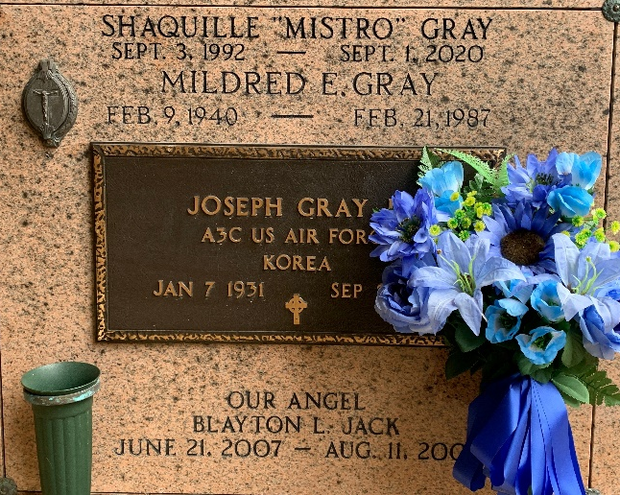
Photo by Team T-Lo

Blayton Loumonth Jack on Saturday, August 11, 2007 at Tulane University Hospital, New Orleans, LA.
Son of Brandi Lynn Jack and Lynncoy Reynaud. Grandson of Christine Gray, Loumonth Jack, Anita Reynaud, and Isiah Thomas. Step grandson of Alicia Jack. Great grandson of Joseph Gray, Ervin Jack, the late Mildred Gray and Leola Jack. Also survived by a host of aunts, uncles, other relatives and friends. Age 1 1/2 months. A native and resident of Laplace, LA.
A Graveside Service will be held today, Thursday, August 16, 2007 at St. Peter Cemetery, 143 West 7th Street, Reserve, LA at 1:00pm. Father Joseph Rodney, Celebrant. SERVICED BY ROBOTTOM.
The Times-Picayune, New Orleans, Louisiana
August 16, 2007

