Annie Mae (Thomas) Jacob
October 2, 1936 – March 18, 1966

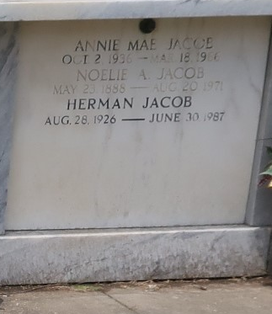

Annie Mae Thomas Jacob, age 30 years, died Friday, 18 Mar 1966.

She was the wife of Herman Jacob and the daughter of Harvey V. Thomas and Mary Poe and sister of Arthur, Earl, Harvey Jr, Roy, Lee, Dorothy, Marie and Alice Ruth Thomas, Lillie Louise Rossen, Neleta Rose Bolding and Mary Elizabeth Powell. She was a native of Arkansas and a resident of Laplace, Louisiana for the past 3 years.

Services were Sunday, 20 Mar 1966 with interment in St. Peter Cemetery, Reserve, Louisiana.
The Times-Picayune, New Orleans, Louisiana
March 20, 1966

