Callan F. Jacob
April 21, 1943 – October 28, 2020

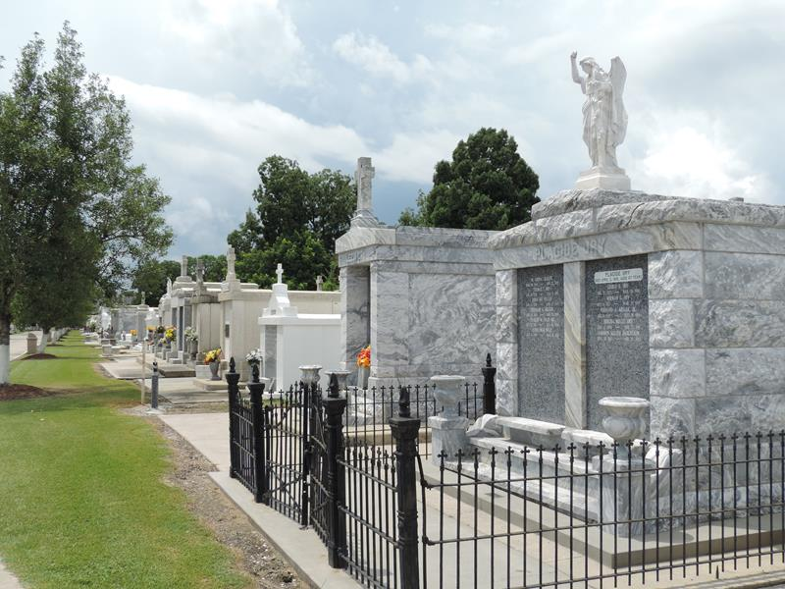

Callan “Cos” F. Jacob, a native and resident of Reserve, passed away on Wednesday, October 28, 2020 at the age of 77.
Callan loved music, photography, playing cards, cooking and his family, especially his four “Peecheez”.
He is survived by his wife of 56 years, Diane Cambre Jacob; son, Callan “Tom” Jacob and wife Chantel; daughter, Sydney J. Perret and husband Darin “Zippy”; grandchildren, Ashton Perret, Tallan Jacob, Caliana Jacob and Drake Perret; brother, Ricky Jacob and wife Marlyn; and sisters, Janie J. Aubert and Doreen J. Waguespack and husband Kirk.
He is preceded in death by his parents, Sidney Jacob and Marie Eve Vicknair; and brother-in-law, Herman Aubert.
A visitation will be held on Monday, November 2, 2020 at St. Peter Catholic Church from 8:30 am until funeral time. A Mass of Christian Burial will be held at 11:30 AM. Interment will follow in the church cemetery.

Rose Lynn Funeral Services, Lutcher, Louisiana

