Debra (Aucoin) Jacob
January 23, 1951 – January 8, 2025

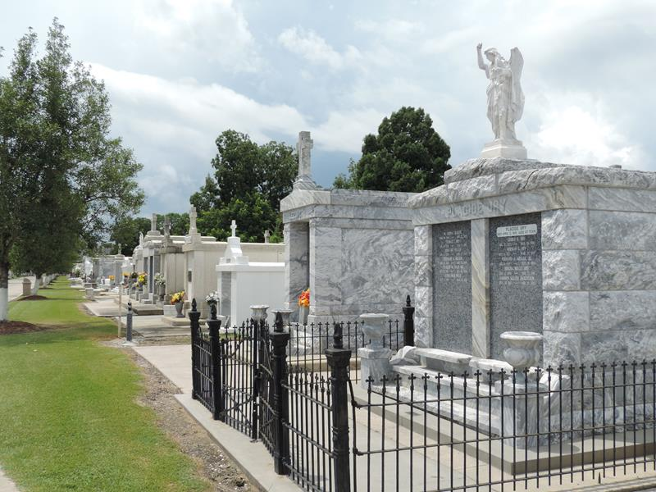

Debra “Debbie” Aucoin Jacob, 73, of Frisco, TX, passed away on January 8, 2025, after a courageous battle with Parkinson’s Disease. She was born on January 23, 1951, in New Orleans, Louisiana, to the late Elphege (EJ) and Jewell Hotard Aucoin.
Debbie was a woman who cherished her family deeply and loved to travel, often creating lasting memories with her children and grandchildren. She found joy in quiet moments, whether enjoying lunch or dinner dates with her devoted husband, or watching college football, especially cheering for her beloved LSU Tigers. A proud graduate of William Carey University, Debbie earned her Bachelor’s degree in Nursing and spent her career caring for others with compassion and dedication.
She was the loving wife of Norman Jacob for 51 years, and a devoted mother to Jeremy (Alicia) Jacob and Amie (Jerry) Brady. As a Nana, she shared her love with Tyler (Rebecca and Aston) and Olivia Jacob, as well as Hannah, Kate, and Lily Brady. Debbie is also survived by her siblings, Randy, Kevin, and Anne Aucoin, and numerous nieces and nephews who will remember her fondly.
A memorial service will be held at a later date in her hometown of Reserve, Louisiana. In lieu of flowers, contributions in Debra's memory may be made to The Michael J Fox Foundation for Parkinson’s Research,
https://www.michaeljfox.org/give-tribute.

Stonebriar Funeral Home, Frisco, Texas

