Doris (Duhe) Jacob
June 29, 1930 – August 2, 2011

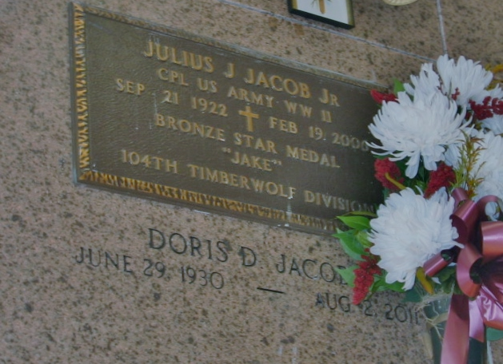
Photo by Bobby

Doris Duhe Jacob passed away on Tuesday, August 2, 2011.
Beloved wife of the late Julius (Jake) Jacob Jr. Daughter of the late Wiltz and Lizzie Clement Duhe. Sister of Eldon Duhe and the late Wiltz Jr., Lloyd and Nolan Duhe, Edda Clement, Evna Boudreaux, Lucille Roussel, Ruth Jumonville and Dorothy Duhe. Also survived by nieces and nephews.
She was a member of the KCA, VFW Auxiliary and American Legion Auxiliary. Age 81. A native and resident of Reserve, La.
Relatives and friends are invited to attend services. Visitation at St. Peter Catholic Church, Reserve, La. on Friday, August 5, 2011 from 9:00 am to 11:00 am, followed by Mass at 11:00 am. Burial in St. Peter Cemetery, Reserve, LA. Arrangements by Millet-Guidry Funeral Home, LaPlace, LA.

Unknown source

