Dorothy (Caruso) Jacob
November 14, 1941 – December 21, 2011

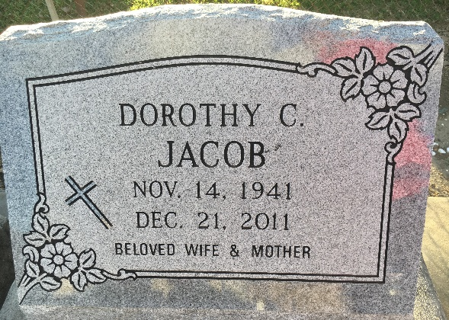
Photo by Team T-Lo

Dorothy Caruso Jacob, 70, passed away peacefully at her home on Wednesday, Dec. 21, 2011, after a courageous battle against lung cancer. She was a native of Baton Rouge and a longtime resident of Reserve. Known affectionately as "Da Da" by her adoring nieces, nephews and grandchildren, and as "Dot" by her devoted friends, she will be remembered for her compassion, hospitality, generosity, openness, kindness, profound sense of fairness and her outstanding cooking.
She is survived by her husband of 44 years, Lawrence A. Jacob; son, Todd Jacob; son and daughter-in-law, Eric and Rochelle Jacob; son, Ryan Jacob; grandsons, Dylan Jacob and Tyler LeBlanc; brother and sister-in-law, Bubbie and Elaine Caruso; sister and brother-in-law, Patsy and Tony Corsentino; sister and brother-in-law, Charlene and Wayne Marchand; stepsister and stepbrother-in-law, Joanne and Allen Hoffberger; sisters-in-law, Shirley Duhe, Norma Woodard, Catherine Keller and Ina Claire Dugas; aunts, Mary Lou Saia, Jean Pinocchi, Nell Gautreaux and Jeanette Braud; nieces and great-nieces, Vickie Cranford, Cindy Evans, Michelle Castille, Jeanne Stuart, Natalie Cooper, Brooke Cranford, Samantha Evans and Soleil Castille; nephews and great-nephews, Vince Caruso, Steve Caruso, Trey Stuart, Nick Caruso, Carson Caruso, Preston Caruso, Taylor Cranford, Tanner Cranford and Luke Evans; and numerous cousins.
She was preceded in death by her parents, Vincent Caruso and Avonna Caruso Pizzuto; stepfather, Vick Pizutto; and stepbrother, Michael Pizzuto. Pallbearers will be Todd Jacob, Eric Jacob, Ryan Jacob, Vince Caruso, Taylor Cranford and Tyler Leblanc.
Visitation will be held Monday, Dec. 26, at St. Peter's Catholic Church in Reserve from 9 a.m. until Mass of Christian Burial at 11 a.m. Interment at St. Peter's Cemetery at noon. In lieu of flowers, please send donations to St. Joseph Hospice, www.StJosephHospice.com. Arrangements by Millet-Guidry Funeral Home, LaPlace.
TheAdvocate.com; Dec. 24 to Dec. 25, 2011

