Felix Joseph Jacob Jr.
April 25, 1933 – October 26, 2023

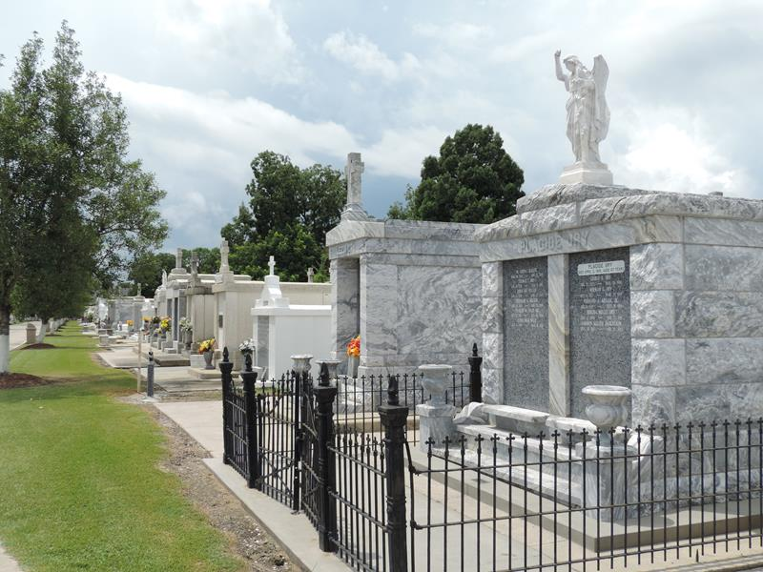

Felix Joseph Jacob, Jr. passed away on Thursday, October 26, 2023 at the age of 90. He was born in New Orleans, LA and was a resident of Reserve, LA.
Beloved husband of Patricia Stein Jacob. Loving father of Barry Jacob (Dawna) and Robin Tassin (Troy). Grandfather of Hunter, Allie, Trace, Madison, Josh (Jessica), Casey (Jill), Chris, Kailee and Aaron. Son of the late Felix J. Jacob, Sr. and Odile Schexnayder Jacob. Brother of Malcolm Jacob and the late Marie Louise Entremont. Also survived by great grandchildren, nieces and nephews.
The family would like to express their heartfelt appreciation to Anvoi Hospice, Myra Cook, the VA Hospital and the Southeast Louisiana War Veterans Home for their loving care.
Relatives and friends are invited to attend the Visitation and Funeral Mass at St. Peter Catholic Church, 1550 Hwy 44, Reserve on Monday, October 30, 2023 from 9:00 a.m. to 11:00 a.m. followed by a Funeral Mass at 11:00 a.m. Interment in St. Peter Cemetery, Reserve, LA.

Rose Lynn Funeral Home, Lutcher, Louisiana

