Frances Leslie (Cali) Jacob
April 6, 1925 – September 22, 2005

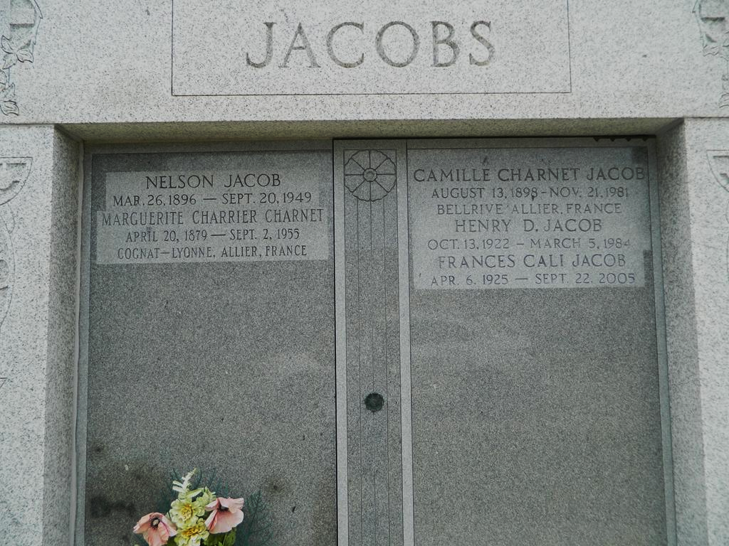

Francis Cali Jacob, 80, a native of the Cravesse area of LaPlace and a resident of the Milesville area of LaPlace and Jayess, MS., died Sept. 22.
She was the wife of the late Henry "Diddy" Jacob. She is survived by her children Nelson "Jake" (Glenna) Jacob, Mary Ann Jacob and Martha (Thomas) Rome. She is also survived by her siblings Josephine C. Guarino and Laura C. Phefferlie, three grandchildren Aaron Lions, Nicole Gray and Ondina Treguerous, three-step-grandchildren David, Mark and Paul Anders, five great-grandchildren and six step-great-grandchildren.
She was preceded in death by her parents Jack and Mary Ann Pizzolato Cali, siblings Michael J. Cali, Johnny J. Cali, Nathanial J. Cali, Norman J. Cali, Conchetta Zito Lemoin, Mary C. Accardo and Rose C. Terry and one grandchild Ashley Lions.
Services were held at St. Joan of Ark Catholic Church, LaPlace, with interment in St. Peter's Catholic Church Cemetery, Reserve.
L'Observateur (La Place, Louisiana)
Thursday, October 13, 2005

