Gabriel Jacob
February 16, 1875 – May 22, 1940

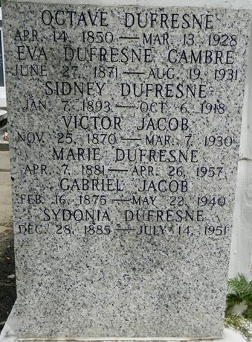

Gabriel Jacob of 3205 St Ann Street died Wednesday 22 May 1940 at age 87 years.

Husband of Sidonia Dufresne, father of Earl L, Clinton J, Gilbert J, Melvin J, and Herbert G Jacob. Brother of Mrs. __ Catoire and Prentice Jacob. A native of St John the Baptist Parish, LA, and a resident of New Orleans for 17 years.
Services at St Peter Church, Reserve, LA, with interment in St Peter Cemetery.

The Times-Picayune, New Orleans, Louisiana
23 May 1940, p. 2

