Gertrude (Hymel) Jacob
February 17, 1923 – June 2, 2010

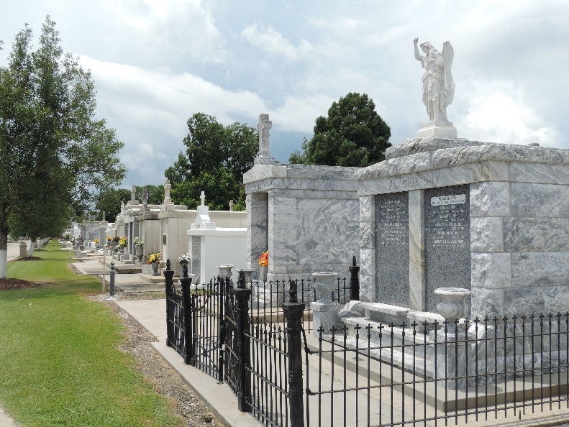

Gertrude Hymel Jacob passed away on Wednesday, June 2, 2010. Beloved wife of the late Andre Jacob. Mother of Andre Jacob Jr. and wife Nancy, Patricia Grady and husband the late Glenn and Jan Sutton and husband Clarence. Grandmother of Dr. Ryan Jacob, Shawn, Glenn and Michael Grady, Tracy Brady and Kelly Fox. Great-grandmother of Evan Brady and Sawyer Fox. Daughter of the late Arthur and Lydia Hymel. Sister of Clyde, Kermit, Robert, Kenneth, Tim and Michael Hymel, Hazel Michel, Elizabeth Ramagos, Veronica Aucoin, Cynthia Schaubhut, Linda Haydel and the late Elmire Vicknair. Age 87. A native and resident of Garyville, La.
Relatives and friends are invited to attend services. Visitation at Millet-Guidry Funeral Home, 2806 W Airline Hwy., LaPlace, La., on Friday, June 4, 2010 from 5:00 pm to 9:00 pm and on Saturday from 8:00 am to 9:30 am. Followed by a Mass at St. Hubert Catholic Church, Garyille, La. at 10:00 am. Burial in St. Peter Cemetery, Reserve.

The Times-Picayune, New Orleans, Louisiana
June 4, 2010

