Guillaume J. Jacob Jr.
November 25, 1898 – October 29, 1968

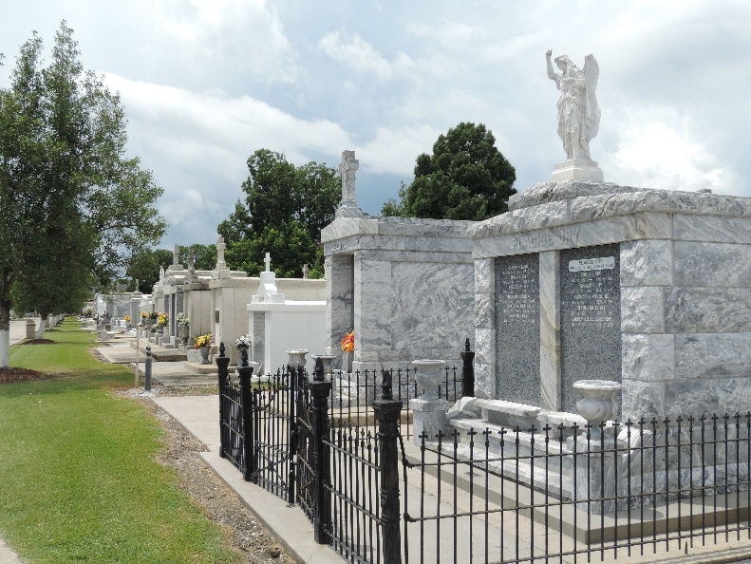

JACOB – on Tuesday, October 29, 1968 at 8 o’clock a.m., Guillaume J Jacob Sr., husband of the late Lucille Matherne, son of Ocenia Vickmair and the late Guillaume Jacob, father of Nolan J. Jacob and Mrs. Joseph Lewis of Reserve, La., Guillaume Jacob Jr. of Birmingham, Ala., Mrs. Victor Ramirez of San Jose, Calif., Mrs. George Andry of Norco, La., Mrs. Jerry Cox of Metairie, La., and the late Kearney Jacob, sister of Mrs. B. F. King of New Sarpy, La., Mrs. Theo Cambre of Reserve, La., Lloyd Jacob of Reserve, La., and the late Emory Jacob, also survived by 18 grandchildren. Age 67 years. A native and resident of Reserve, La.
Relatives and friends of the family are invited to attend the funeral. Services from Millet Funeral Home, Reserve, La. On Thursday, October 31, 1968 at 1 o’clock a.m. Religious services at St. Peter’s church, Reserve, La. Interment in Church cemetery. Friends may visit after 4 p.m. on Wednesday.

New Orleans States-Item, Louisiana
Wednesday, October 30, 1968, p. 4

