Horace Jacob
1900 – June 16, 1914

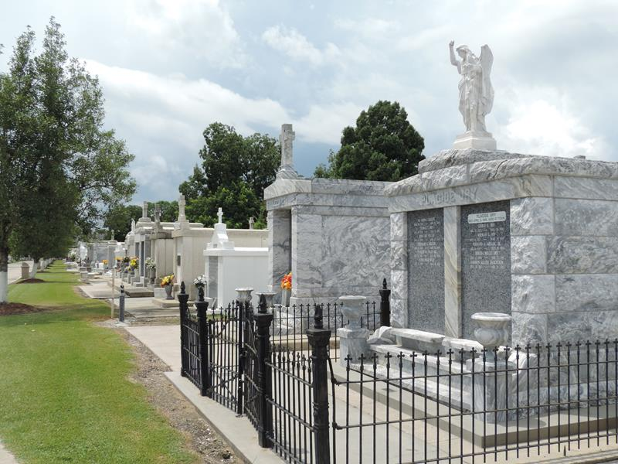

Young Jacob Drowns In Pond

Last Tuesday evening at 4:30 o’clock Horace Jacob, the young son of Camille Jacob, a very highly esteemed citizen of this parish was accidentally drowned in a pond on Cornland Plantation between the two levees.
This pond was used to irrigate the rice land on the Cornland Plantation. Immediately after enjoying a hearty meal young Jacob left for the river front with two pieces of bread. A few minutes later he entered this pond and went to the bottom.
When caught he was still alive, but died ten minutes after. He was 13 years, and 6 months old at the time of his sad death. The funeral took place last Wednesday at 4:30 p.m., Rev. Father Badeaux officiating. All that was mortal of this youth were gently laid to rest in the St. Peter’s Cemetery at Reserve, La.
Besides a devoted father, he leaves to mourn his untimely loss, one brother Victorin Jacob, one sister Jeanne Jacob, and many friends.
In this life’s greatest trial we beg to extend to the bereaved ones our most heartfelt and sincere sympathetic expression of condolence.

Le Meschacebe, Lucy, Louisiana
June 20, 1914

