James Curtis Jacob
March 20, 1930 – December 16, 2021

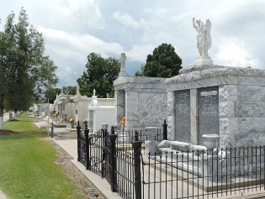

James Curtis Jacob passed away on Thursday, December 16, 2021 at the age of 91. He was a native of Good Hope, LA and a resident of Metairie.
He graduated from S. J. Peters High School in 1948. Proudly served 12 years in the U. S. Naval Reserves. He was an insurance agent for over 60 years. Mr. Jacob received awards for his volunteer efforts, including St. Vincent de Paul, Hospice, ARC, and many others. He loved spending time with his family and friends, outdoor activities and dancing. He was loved and respected by everyone who knew him.
Beloved husband of Olga Marina Jacob, for 43 years. Loving father of Deborah Anne Jacob, Judy Jacob Kangas (Larry), Joan Jacob McPherson (Tom), Connie Jacob O'Loughlin (Dave), Lorrie Jacob Ducarpe (Bob), Ellen Jacob Speice (John), Ana Maria Gonzalez, Jasmine Guevara Arias (Jose Manuel), Egla Guevara Trujillo (Jose), Jorge Espinal (Cheryl), Arlen Espinal (Ashley) and Olga Marina LaBeau (Nate). Also survived by 27 grandchildren, 22 great grandchildren, Rocky Ducarpe and numerous nieces and nephews.
Son of the late Rena Giroir Jacob and Claus Joseph Jacob. Brother of the late Claus Joseph Jacob, Jr.(Claire), Yolande Jacob St. Pierre( Ronald) and Ronald Jacob (Winnie).
Relatives and friends are invited to attend the Visitation and Memorial Mass at L. A. Muhleisen & Son Funeral Home, 2607 Williams Blvd., Kenner on Monday, December 20, 2021. Visitation from 8:00 a.m. to 10:00 a.m. followed by a Memorial Mass at 10:00 a.m. Interment in St. Peter Catholic Cemetery, Reserve, LA
L.A. Muhleisen & Son Funeral Home, Kenner, Louisiana
Dec. 17, 2021

