Julius J. Jacob Jr.
September 21, 1922 – February 19, 2006

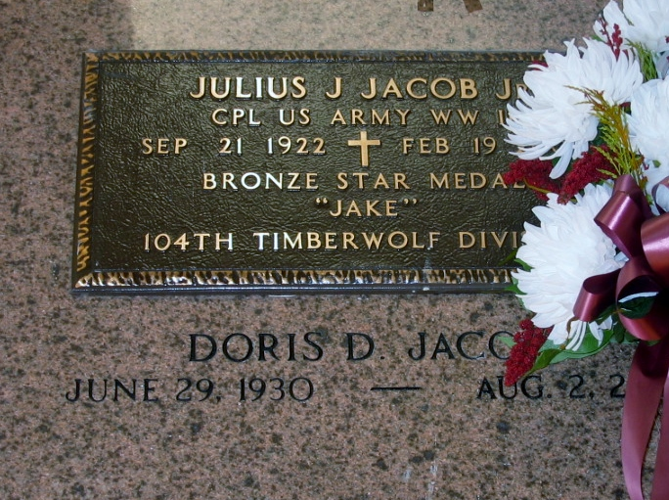
Photo by Bobby

Julius (Jake) Jacob, Jr. passed away on Sunday, February 19, 2006.
Beloved husband of Doris Duhe Jacob. Son of the late Julius and Pauline Jacob. Raised by Ernest and Margaret Landry. Brother of Zelma Vicknair and Joseph Lee Jacob. Also survived by numerous nieces and nephews.
A World War II Veteran (Timberwolf Div. 104) and a recipient of The Bronze Star. Age 83. A native and resident of Reserve.
Relatives and friends of the family, also members of VFW Post 5004 and American Legion Unit 159, are invited to attend services. Visitation at Millet-Guidry Funeral Home, 2806 W. Airline Hwy., Laplace, LA, on Wednesday, February 22, 2006, from 11:00 a.m. to 1:00 p.m. Followed by Religious Services at St. Peter Catholic Church, Reserve, LA. at 1:30 PM. Burial in Church Cemetery.
Times Picayune, New Orleans, Louisiana
February 21, 2006

