Lida (Cambre) Jacob
March 20, 1888 – April 14, 1967

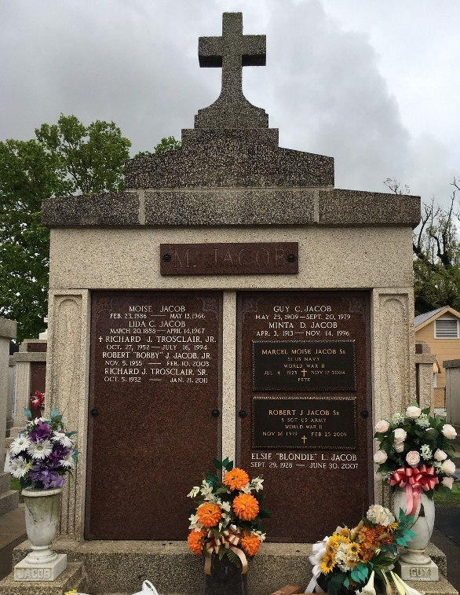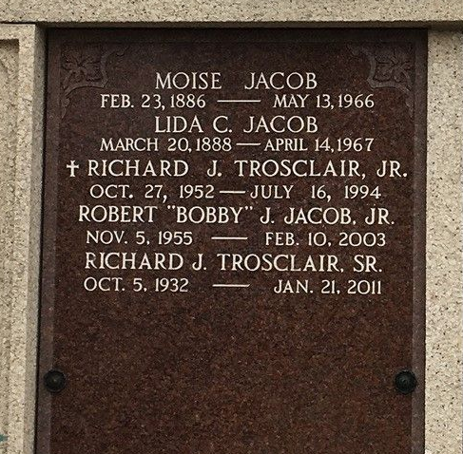
Photo by Team T-Lo

Age 79 years, a native and resident of Reserve, Louisiana.

Wife of the late Moise Jacob and mother of Guy, Robert and Marcel Jacob and Mrs. Frank Guillot all of Reserve, Mrs. Richard Trosclair of Norco, Louisiana, Harry, Alton and Leonard Jacob all of Baton Rouge. Sister of Mrs. Camille Naquin of Baton Rouge, Georgina and Lewis Cambre of Reserve.

Services were Monday, 17 Apr 1967 at St Peter Church in Reserve, with interment in St Peter Cemetery, Reserve.
Times Picayune, New Orleans, Louisiana
April 15, 1967

