Lois (Simon) Jacob
November 23, 1931 – June 4, 2025

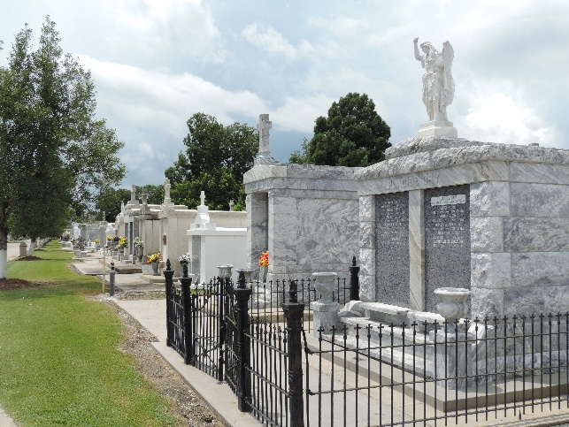

Lois Simon Jacob was born on November 23, 1931, at home in Reserve, Louisiana. She was the youngest of eleven (11) children born to Joseph and Lena Simon. She was a lifelong Catholic who was a member of St. Peter Catholic Church, Reserve, La. until 1950 when she married Jean D. Jacob also of Reserve, La. and relocated to Metairie, La. In 1951. She had 4 children – Janel, Rickie, Bruce and Barry. Sadly, her marriage to Jean ended in divorce after 33 years. She was a devoted mother, grandmother, great grandmother, great-great grandmother, daughter, sister, and aunt.
In her younger years Lois enjoyed sewing, bowling, Mardi Gras Balls and was always involved with and supportive of her children’s varied activities and was also an avid reader of the printed word. During her later years she returned to her roots and moved back to Reserve to become a loving caregiver for her mother and many of her siblings.
Lois was preceded in death by her former husband, Jean D. Jacob, by her son Rickie George Jacob, as well as all 10 of her siblings: Velma Williams, Elise Simon, Henry Simon, Andrew Simon, Arthemise (Mimmy) Rebler, Antoine Simon, Willie Simon, Therese’ Brennan, and Rene’ Simon.
Lois passed away peacefully after a brief illness in the very same home where she was born 93 years earlier, under the care of her devoted son Bruce. She leaves behind daughter Janel Jacob Masson, sons Bruce Joseph Jacob and Barry Wayne Jacob, several grandchildren, great grandchildren, great-great grandchildren, many nieces and nephews, as well as a host of relatives and friends.
God in His infinite mercy and wisdom has called Lois home. She will be remembered as a faithful servant and kind soul by her family members. May she rest in peace for all eternity.
Services officiated by Fr. Ray Hymel will be held on Friday July 18, 2025, beginning at 10 AM with a rosary and Mass at Millet-Guidry Funeral Home located at 2806 W. Airline Hwy. LaPlace, La. 70068. Interment will follow the service at St. Peter Catholic Cemetery located at 1550 La. 44, Reserve, La. 70084.

Millet-Guidry Funeral Home, LaPlace, Louisiana

