Marcel Moise Jacob Sr.
July 4, 1923 – November 17, 2004

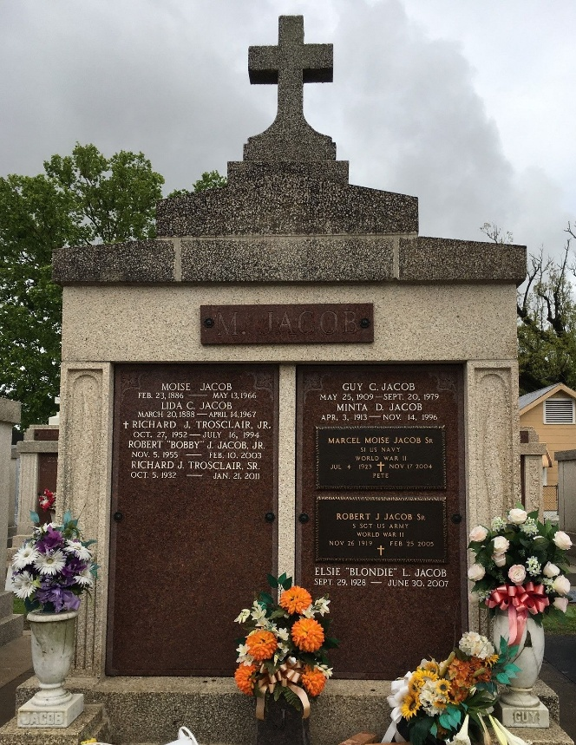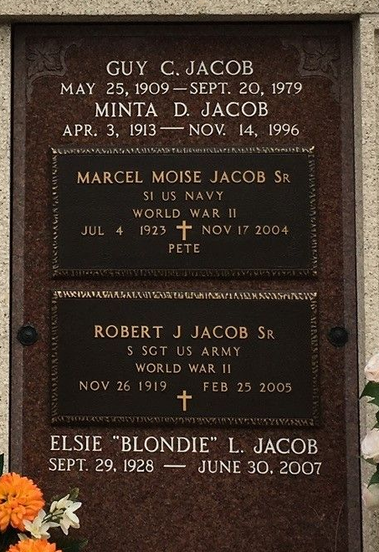

"Pete" was the beloved husband of Elsie Landry Jacob, father and father-in-law of Sandra J. and Jimmy Ray Madere, Marcel Jr. and Terri Jacob and Sharon and Mickey Snyder, brother of Shirleen Trosclair, Harry, Leonard and Robert Jacob and the late Alma Guillot and Guy and Allain Jacob, son of the late Moise and Lydia Cambre Jacob, grandfather of Danielle Calix, Marcie Hebert, Beth Fincher, Mandy Jacob, Holly Snyder and Matthew Madere, and great-grandfather of Abrielle Stoltz, Lanie Fincher, Maggie Calix, Bryce Fincher and Patrick and Hayden Hebert.
He was 81 and a lifelong resident of Reserve.

Unknown source

