Maria (Jacob) Jacob
January 12, 1890 – August 8, 1974

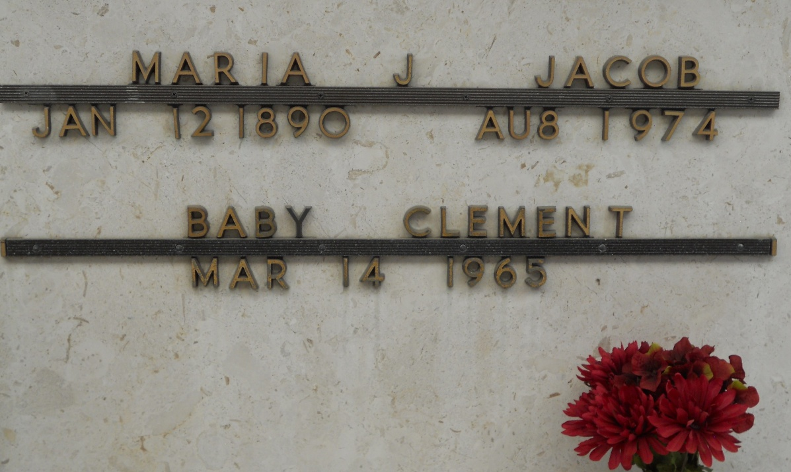
Photo by Team T-Lo

Maria Jacob, of Reserve, La, on Thursday, August 8, 1974, at 11:00 o'clock a.m., beloved wife of the late Prentice Jacob Sr., mother of Ernest Jacob Jr. of New Orleans, La., Norman Jacob, Venita Cambre, Mrs. Alden (Vera) Clement, all of Reserve, La., sister of George Jacob and Louisa Jacob, both of Reserve, La., also survived by 7 grandchildren, and 3 great grandchildren, age 84 years, a native and resident of Reserve, La.

Relatives and friends of the family, also Callander Air Base of Belle Chasse, La, and employes of Reily Chemical Co of New Orleans, La, are invited to attend the funeral. Services from Millet Funeral Home, Reserve, La., on Saturday, August 10, 1974 at 10:00 o'clock a.m., followed by religious services at St Peter Catholic Church. Interment in St Peter Cemetery, Reserve, La.
The Times-Picayune, New Orleans, Louisiana
9 Aug 1974, p. 18

