Marian (Triche) Jacob
November 5, 1927 – August 22, 1999

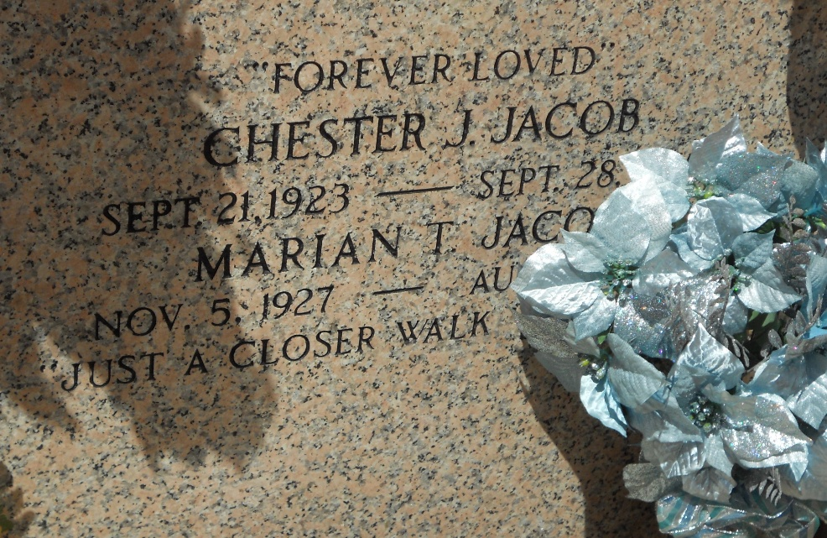
Photo by Team T-Lo

Marian Triche Jacob died Sunday 22 Aug 1999 at 8:45 am at age 71 years. She was a native and lifelong resident of Reserve, Louisiana.

Wife of the late Chester J. Jacob and mother of Tamara J. McClung of Gramercy, Louisiana, Dana J. Caldarera and Blaine Jacob both of Reserve, and mother-in-law of Joslyn P. Jacob and Chris Caldarera of Reserve and Paul McClung of Gramercy. She was the daughter of Charles J. and Antoinette Catoir Triche and sister of George Warner Triche of Reserve, Allen Triche of Laplace, Louisiana, Gloria T. Lanier of Ponchatoula, Louisiana, Sherry Migues of Biloxi, Mississippi and the late Charles (Pickle) Triche Jr., and Donald Triche.

Services were Tuesday, 24 Aug 1999, at St Peter Church, Reserve, with interment in St Peter Cemetery, Reserve.
The Times-Picayune, New Orleans, Louisiana
August 23, 1999

