Moise Jacob
February 23, 1886 – May 13, 1966

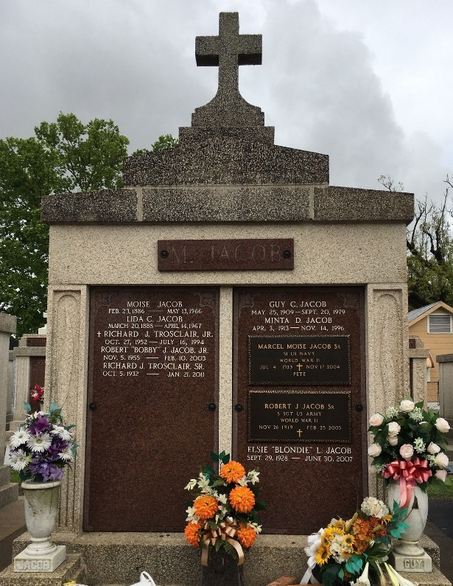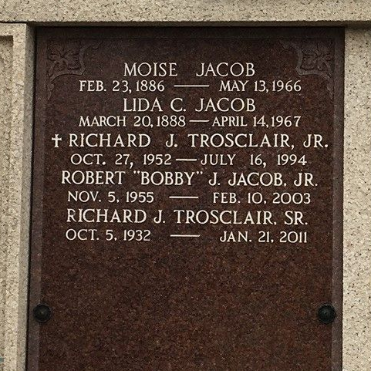
Photo by Team T-Lo

Age 80 years, a native and resident of Reserve, Louisiana.

Husband of Lida Cambre and father of Guy, Robert and Marcel Jacob, Mrs. Frank Guillot and Mrs. Richard Troxclair, all of Reserve, Harry, Allain and Leonard Jacob of Baton Rouge.

Services were Monday 16 May 1966 at St Peter Church, Reserve, with interment in St Peter Cemetery, Reserve.
The Times-Picayune, New Orleans, Louisiana
May 15, 1966

