Nellie (Louque) Jacob
November 20, 1909 – January 5, 1999

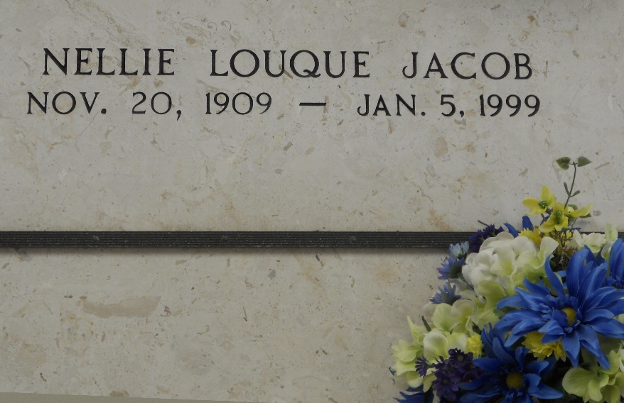
Photo by Team T-Lo

Nellie Louque Jacob, 89, a native of Grand Point and resident of Reserve for the past 70 years, died Jan. 5. She was the wife of the late Wilson Jacob and mother of two.
She was also the daughter of the late Adrien and Adorestine Bourgeois Louque and sister of Viola Duhon.
She is also survived by 12 grandchildren and 29 great-grandchildren.
Services were held Jan. 8 at St. Peter Catholic Church, Reserve, with interment at the church cemetery.
L’Observateur, LaPlace, Louisiana
January 11, 1999

