Octavie (Madere) Jacob
July 26, 1851 – December 26, 1925

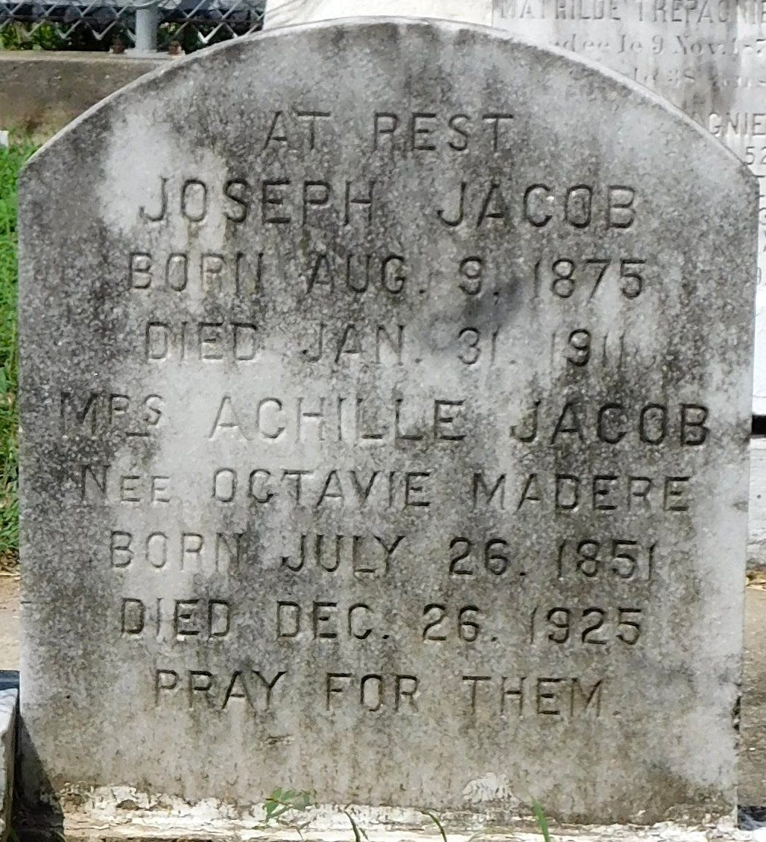
Photo by Mary Agnes Hammett

Mrs. Achille Jacob née Octavie Madere died at the Laplace, LA, home of her son-in-law, Ernest Vicknair, last Saturday [26 Dec 1925] at age 74 years and 6 months. Interment next day at St Peter Cemetery, Reserve, LA.

L'Observateur, LaPlace, Louisiana
January 2, 1926

